<https://www.youtube.com/watch?v=OtD8wVaFm6E&list=PLblh5JKOoLUICTaGLRoHQDuF_7q2GfuJF&index=59>





Today we're gonna talk about XGBoost part 1.

We're gonna talk about XGBoost trees and how they're used for regression.

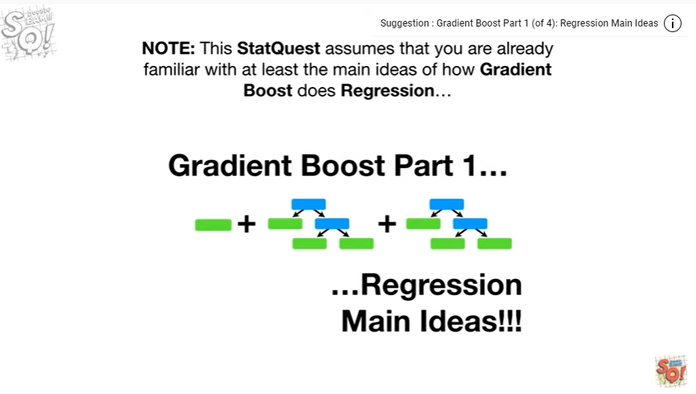

Note : this stat quest assumes that you are already familiar with at least the main ideas of how gradient boost does regression.

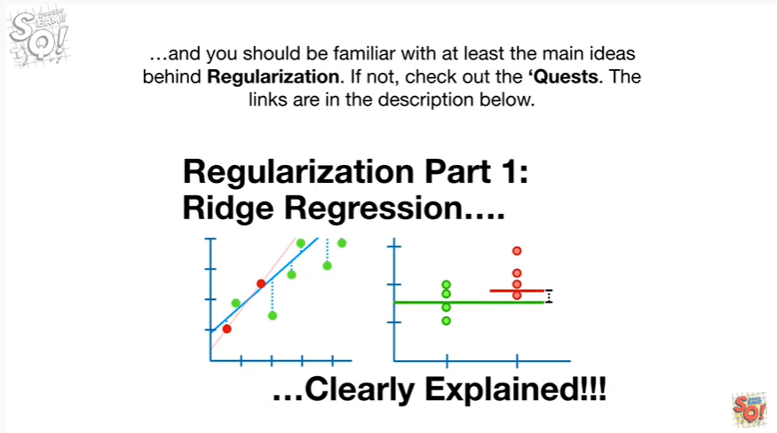

And you should be familiar with at least the main ideas behind regularization, if not check out the quests.

The links are in the description below.



XGBoost is extreme !!!!

And that means it's a big machine learning algorithm with lots of parts.



The good news is that each part is pretty simple and easy to understand, and we'll go through them one step at a time.

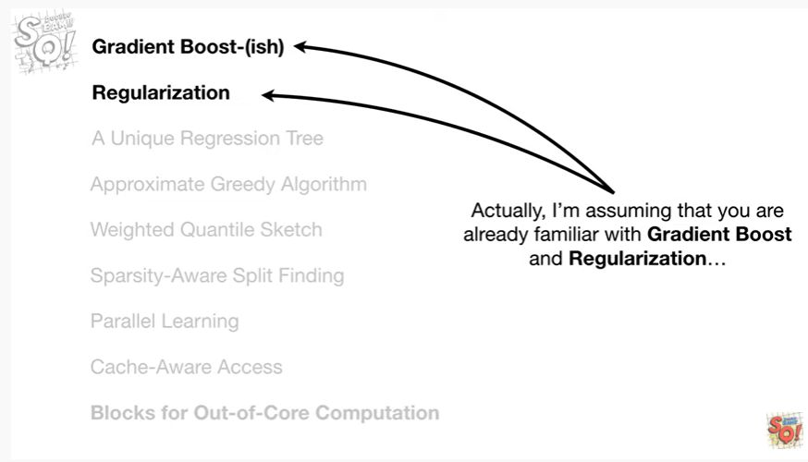

Actually I'm assuming that you are already familiar with gradient boost and regularization.

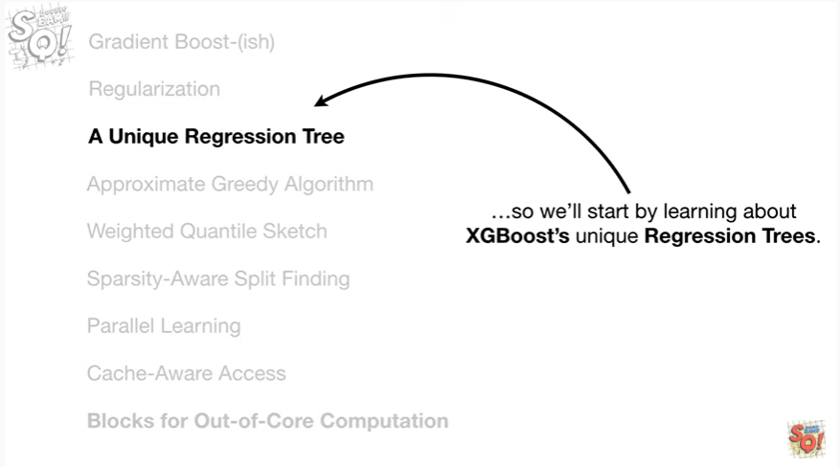

So we'll start by learning about XGBoosts unique regression trees.

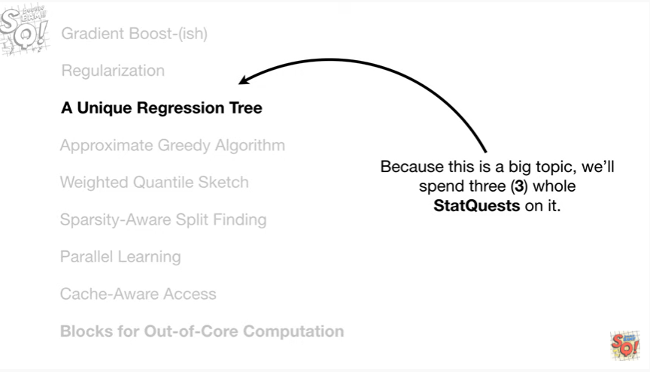

Because this is a big topic will spend three whole stack quests on it.

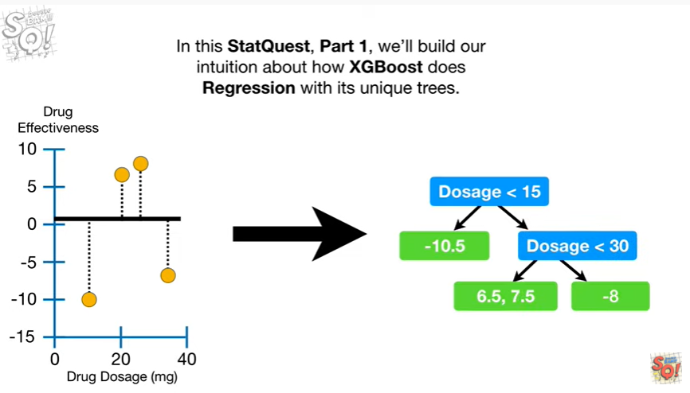

In this stack quest, part 1, will build our intuition about how XGBoost does regression with its unique trees.

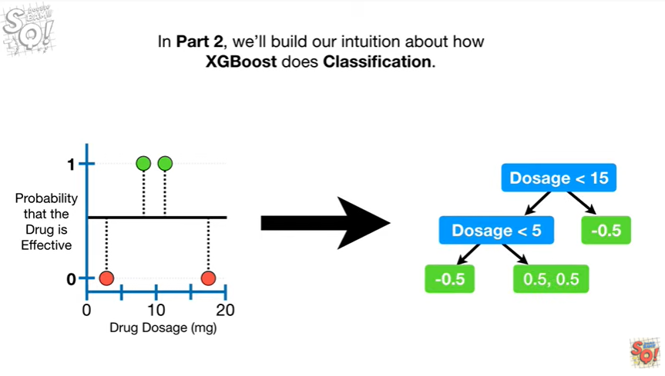

In part two, we'll build our intuition about how XGBoost does classification.

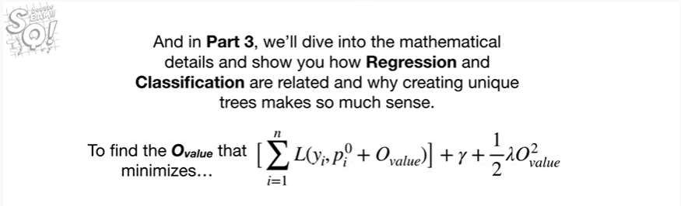

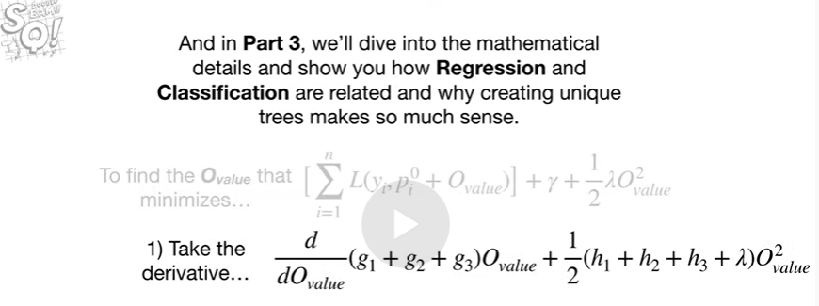

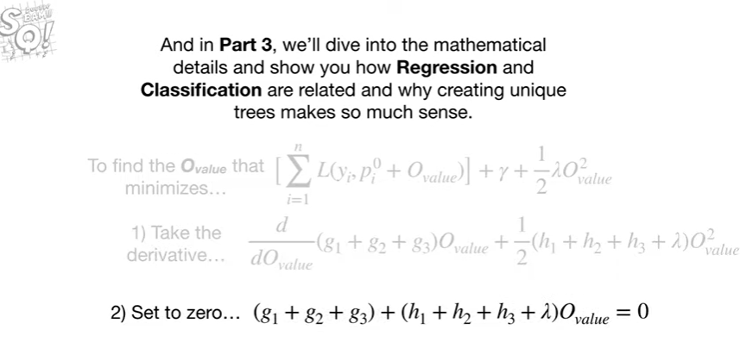

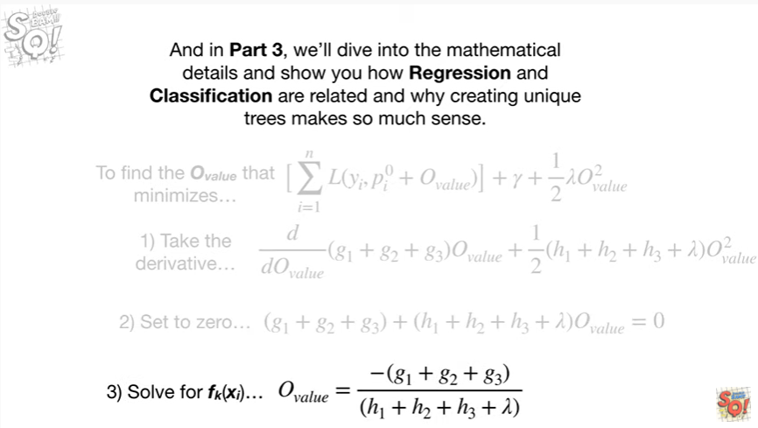

And in part three, we'll dive into the mathematical details and show you how our aggression and classification are related and why creating unique trees makes so much sense.

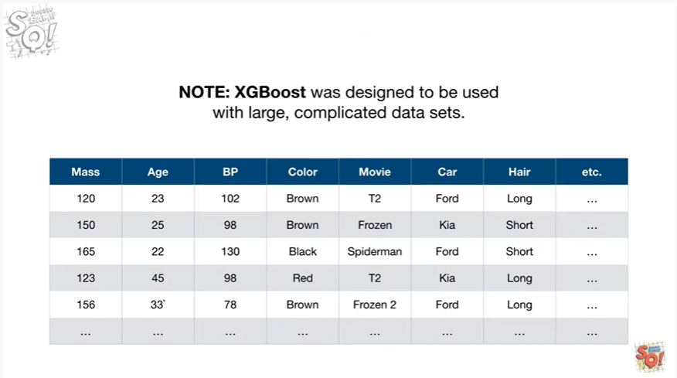

Note : xgboost was designed to be used with large, complicated datasets.

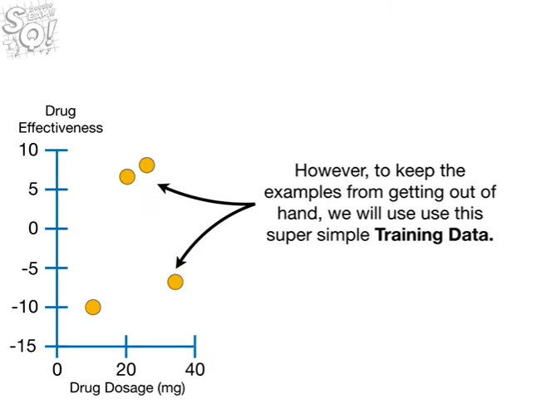

However, to keep the examples from getting out of hand, we'll use this super simple training data.

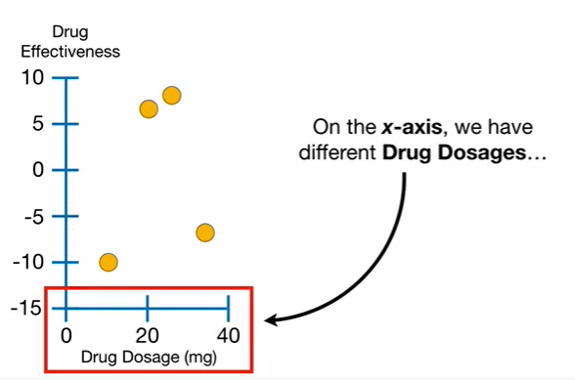

On the x-axis we have different drug dosages

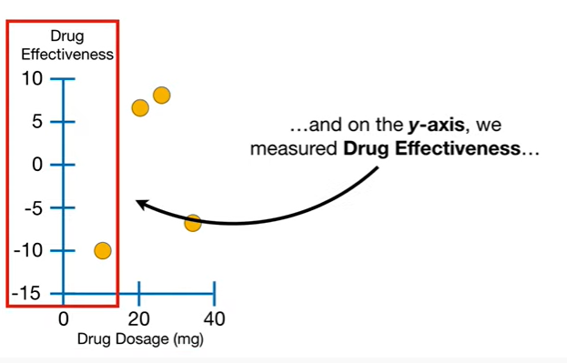

and on the y-axis we've measured drug effectiveness.

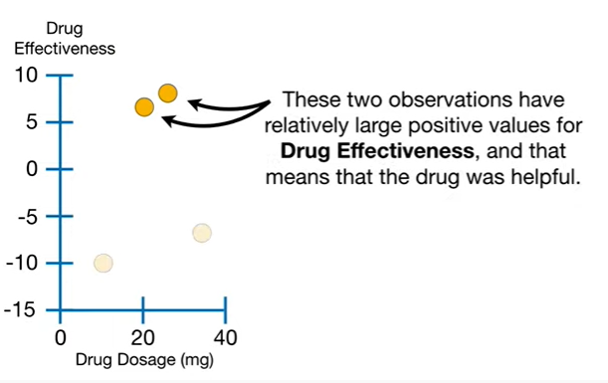

These two observations have relatively large positive values for drug effectiveness, and that means that the drug was helpful.

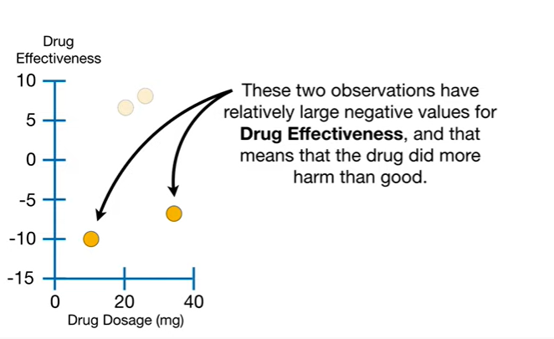

These two observations have relatively large negative values for drug effectiveness, and that means that the drug did more harm than good.

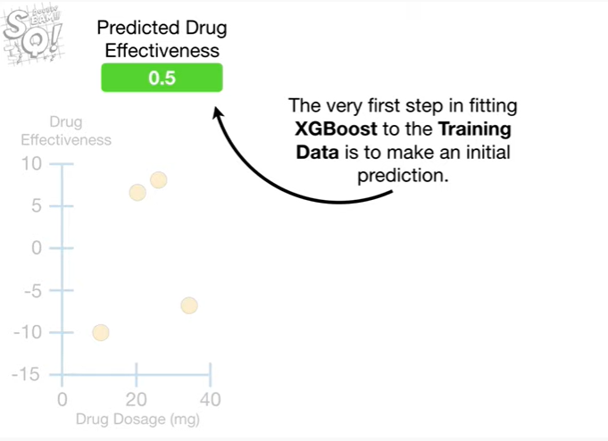

The very first step in fitting XGboost to the training data is to make an initial prediction.

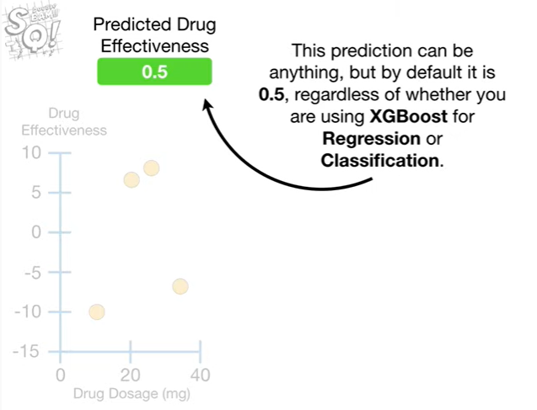

This prediction can be anything but by default it is 0.5, regardless of whether you're using XGBoost for regression or classification.

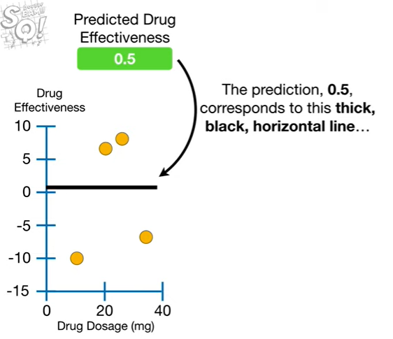

The prediction, 0.5, corresponds to this thick black, horizontal line

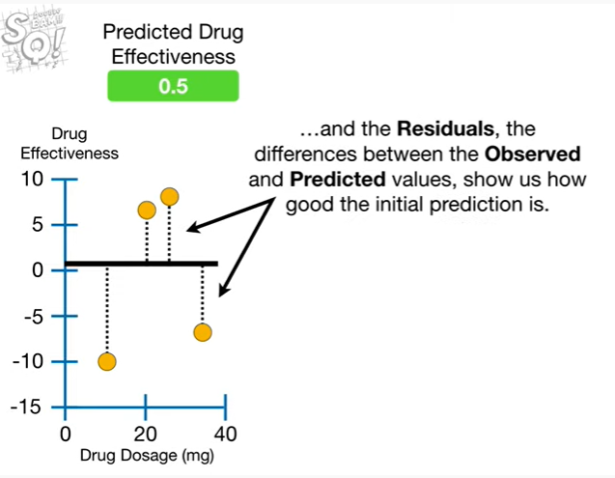

and the residuals the differences between the observed and predicted values, show us how good the initial prediction is.

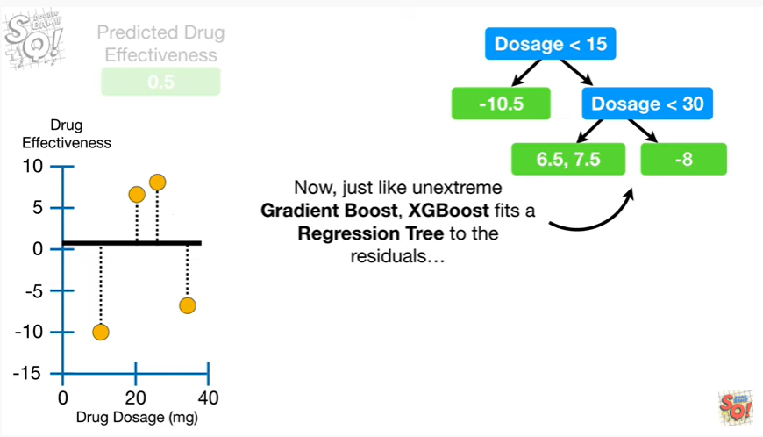

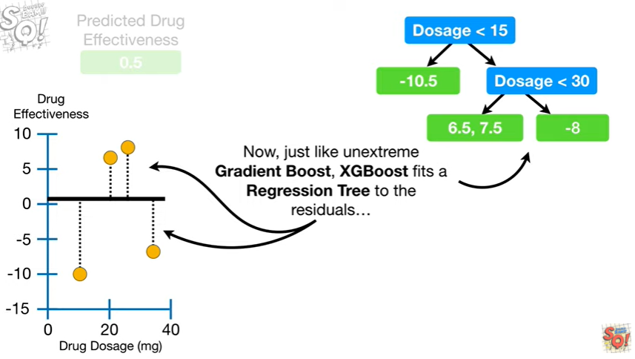

Now just like unextrem gradient boost, XGboosts fits a regression tree to the residuals.

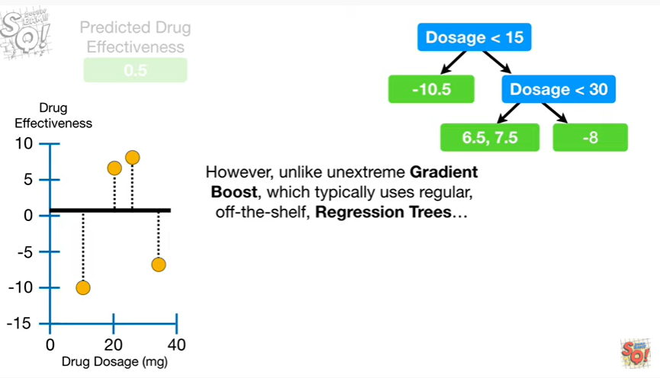

However, unlike unextrem gradient boost, which typically uses regular off-the-shelf, regression trees

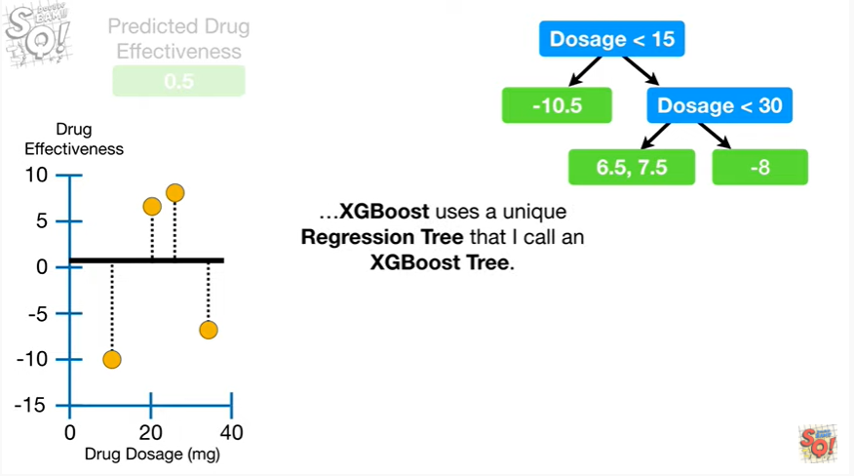

XGboost uses a unique regression tree that I call an XGBoost tree.

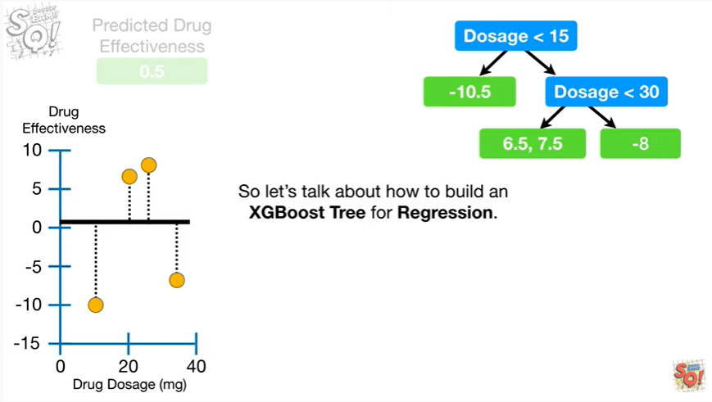

So let's talk about how to build an XGBoost tree for regression.

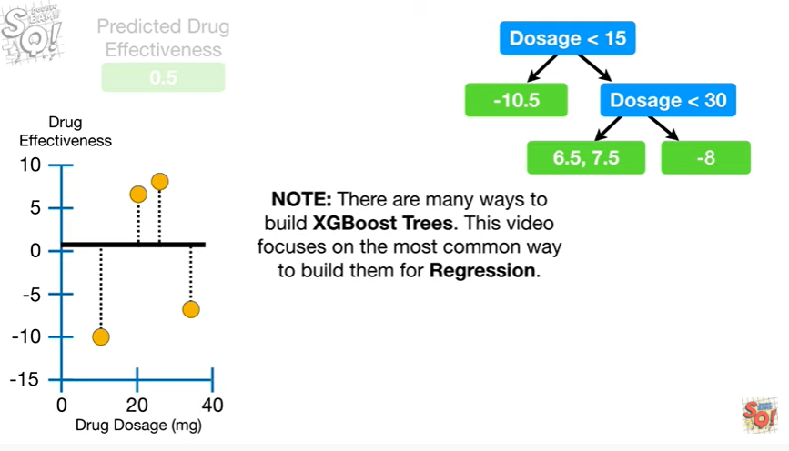

Note : there are many ways to build XGBoost trees this video focuses on the most common way to build them for regression.

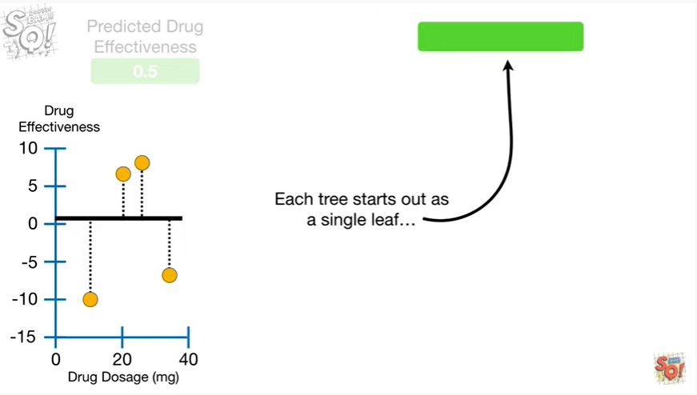

Each tree starts out as a single leaf

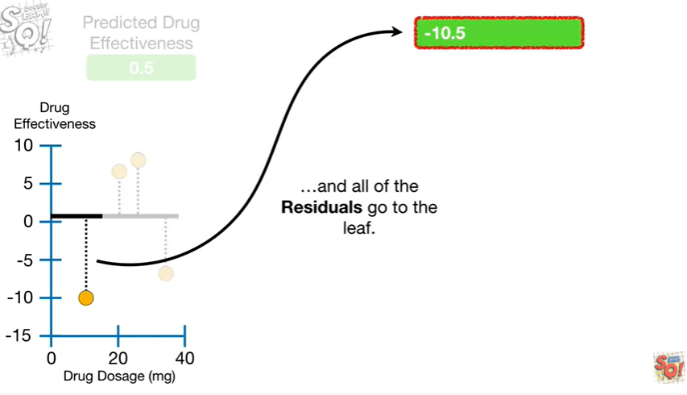

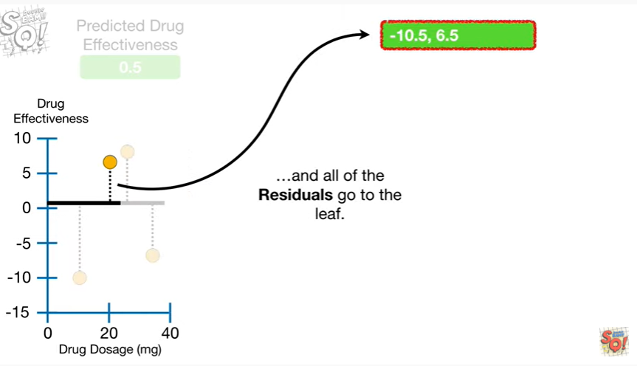

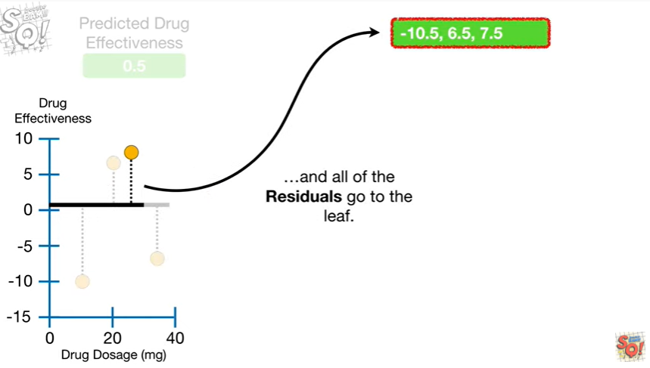

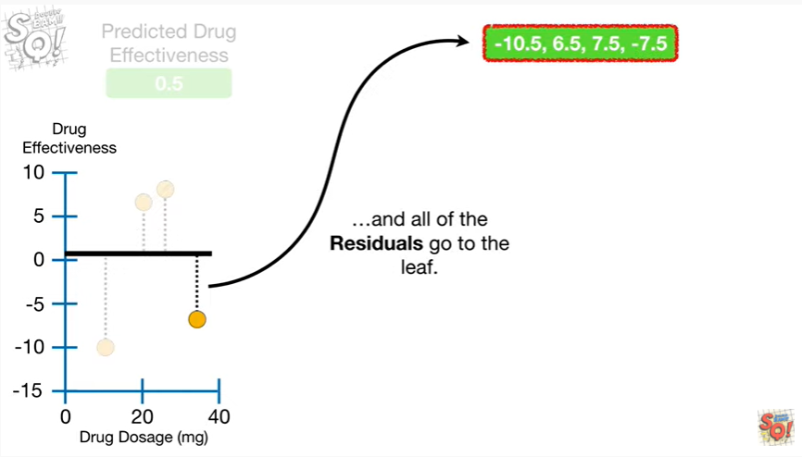

and all of the residuals go to the leaf.

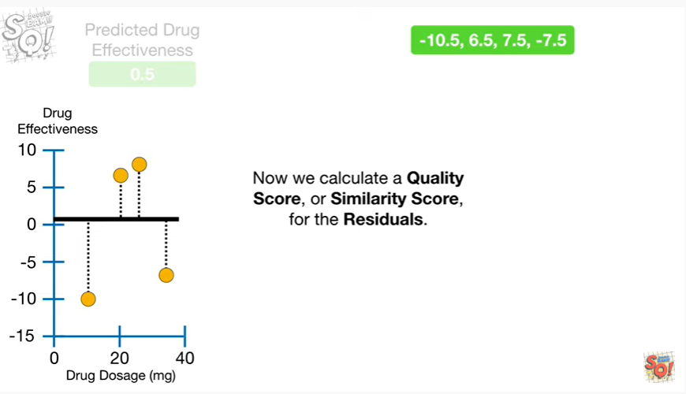

Now we calculate a quality score or similarity score, for the residuals.

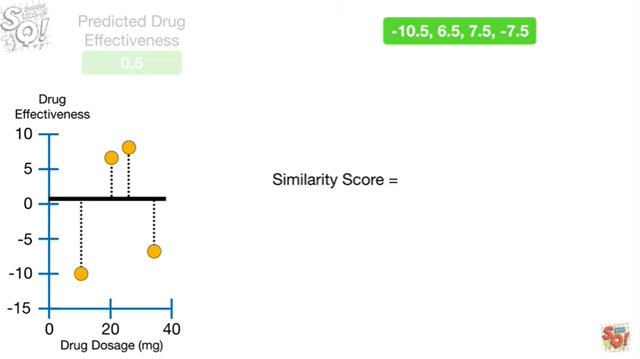

Similarity score equals

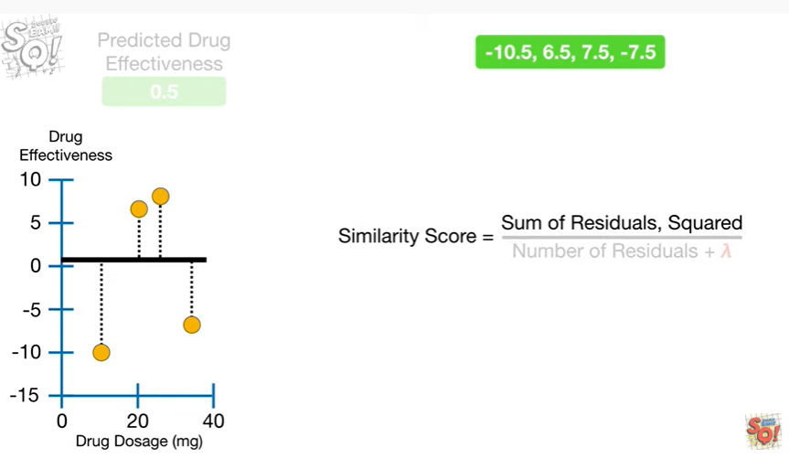

the sum of the residuals squared

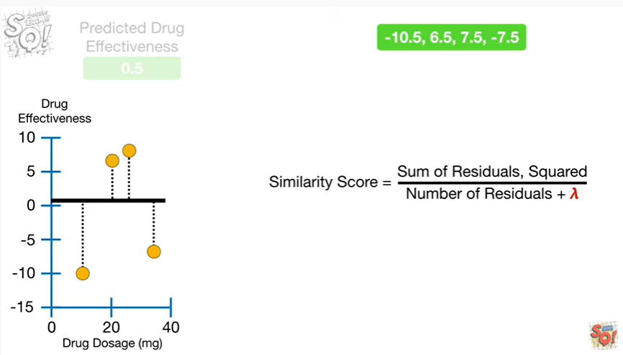

over the number of residuals plus lambda.

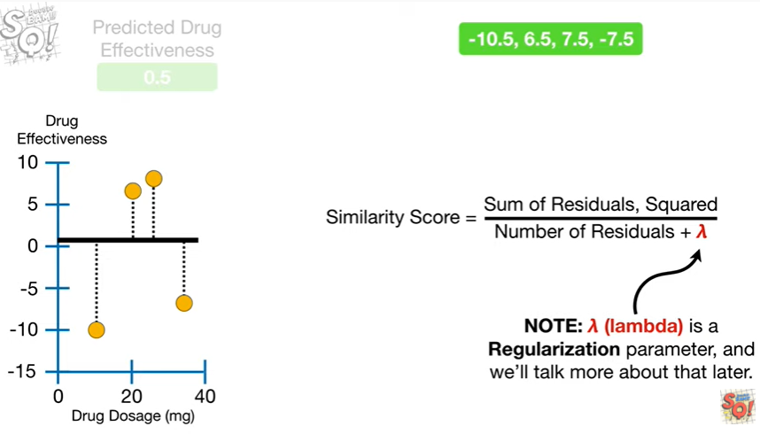

Note : lambda is a regularization parameter and we'll talk more about that later.

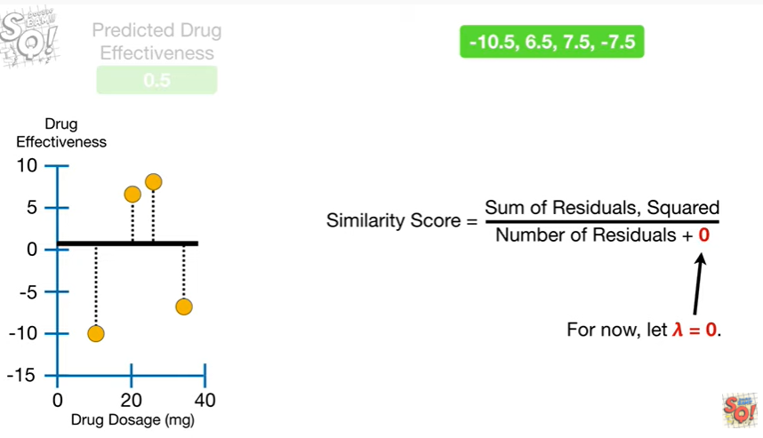

For now, let lambda equals zero.

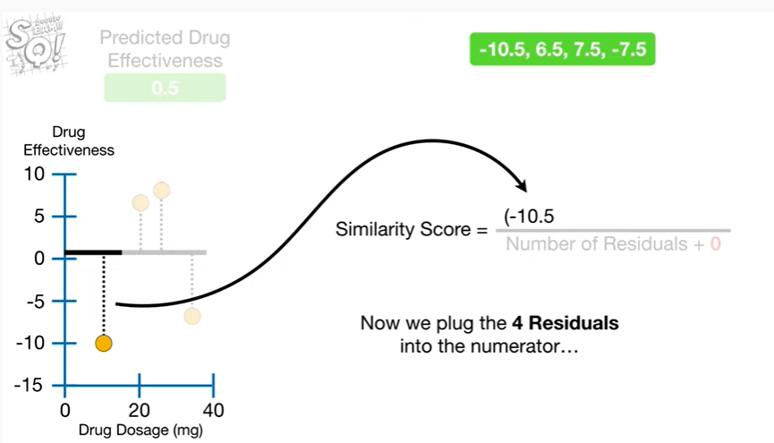

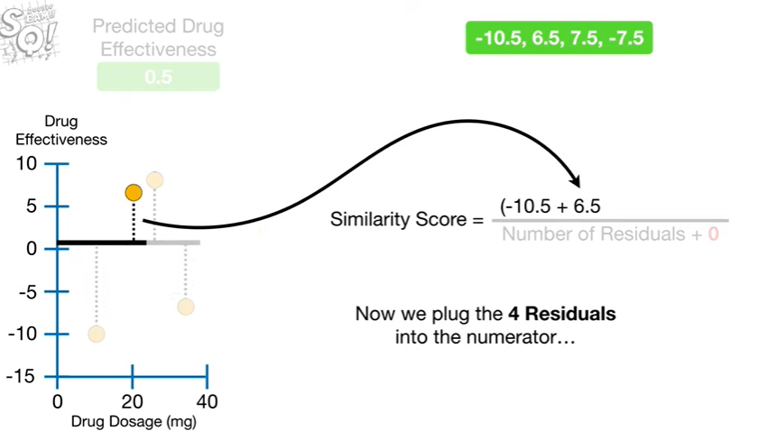

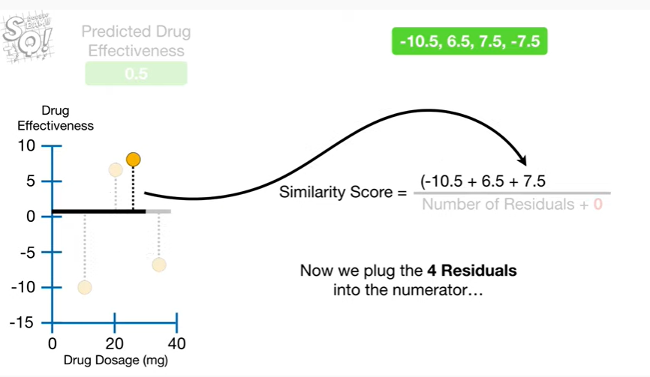

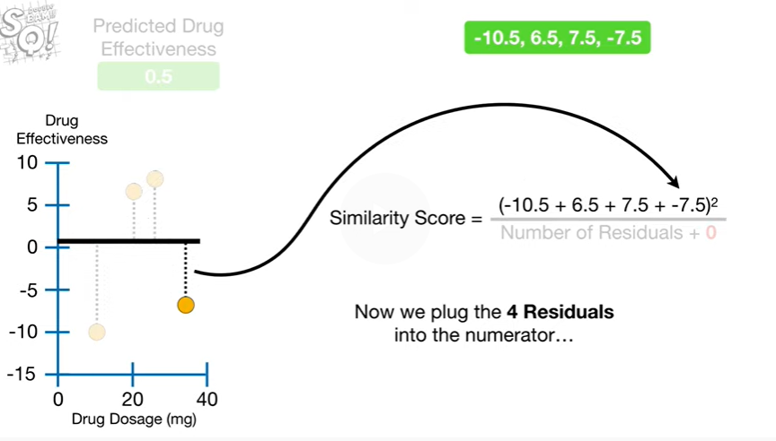

Now we plug the for residuals into the numerator

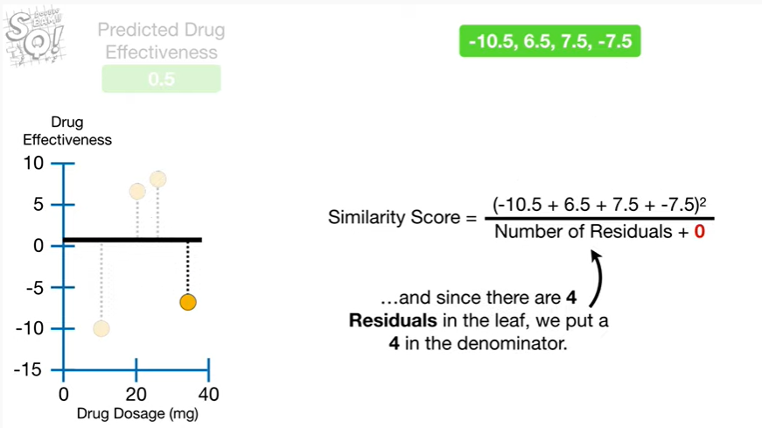

and since there are four residuals in the leaf we put a four in the denominator.

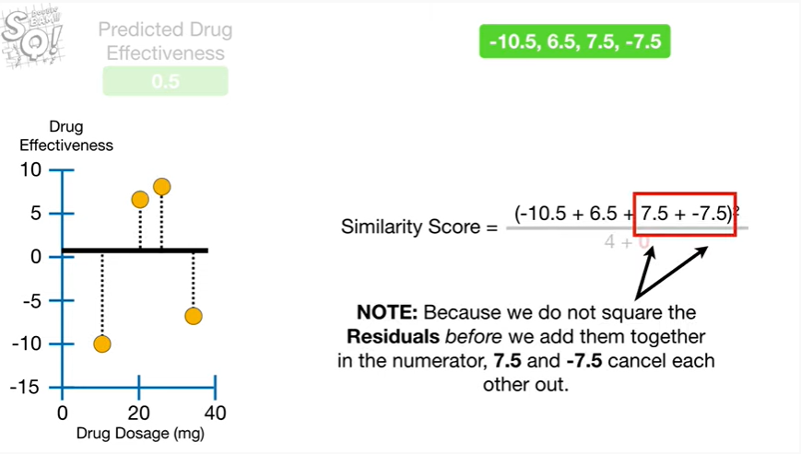

Note : because we do not square the residuals before we add them together in the numerator, 7.5 and negative 7.5 cancel each other out.

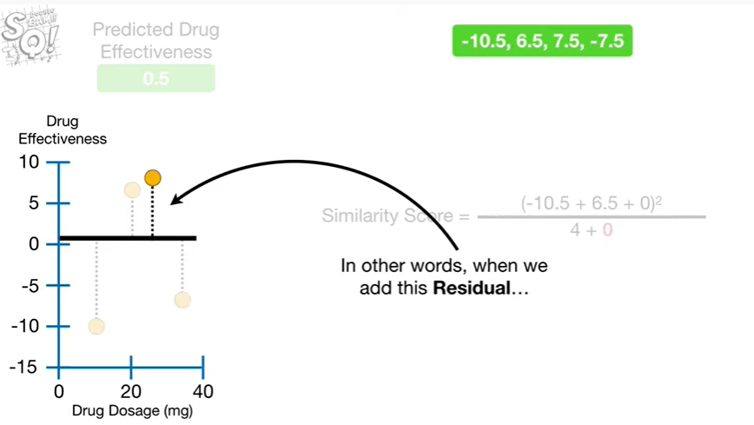

In other words, when we add this residual

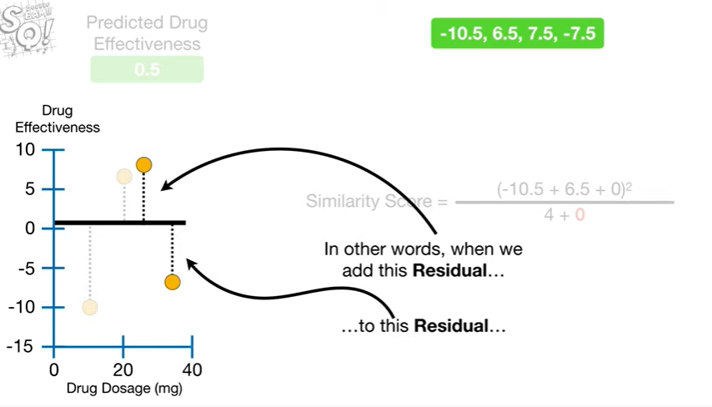

to this residual

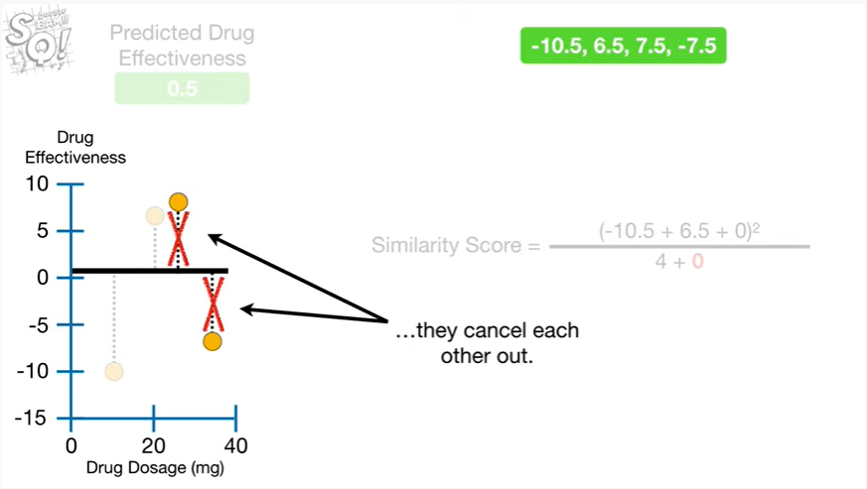

they cancel each other out.

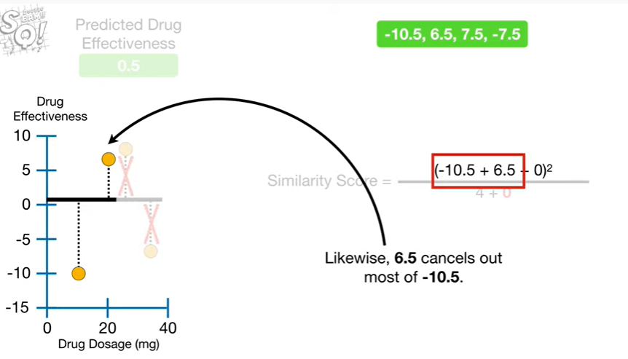

Likewis,e 6.5 cancels out most of negative 10.5.

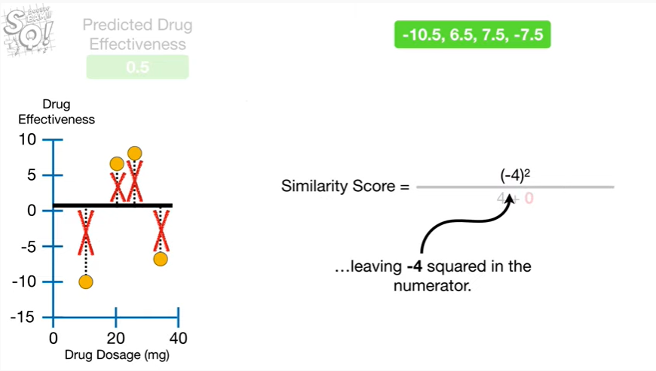

Leaving negative 4 squared in the numerator.

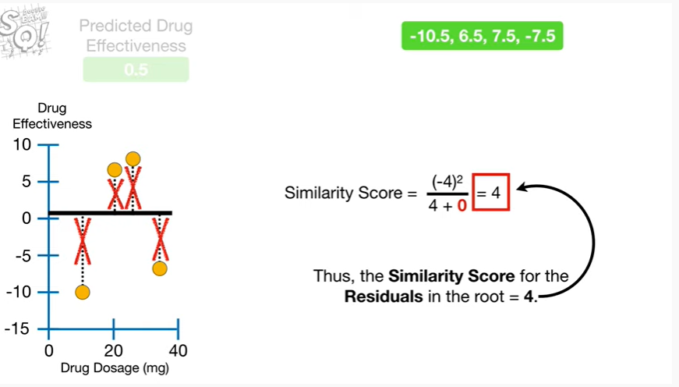

Thus, the similarity score for the residuals in the root equals 4.

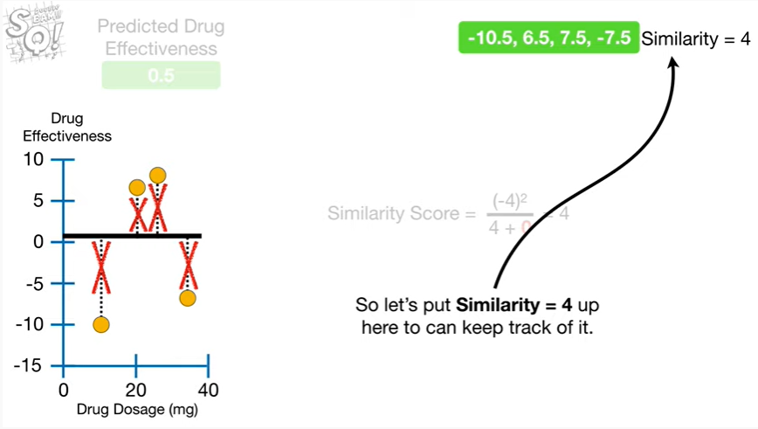

So let's put similarity equals 4 up here, so we can keep track of it.

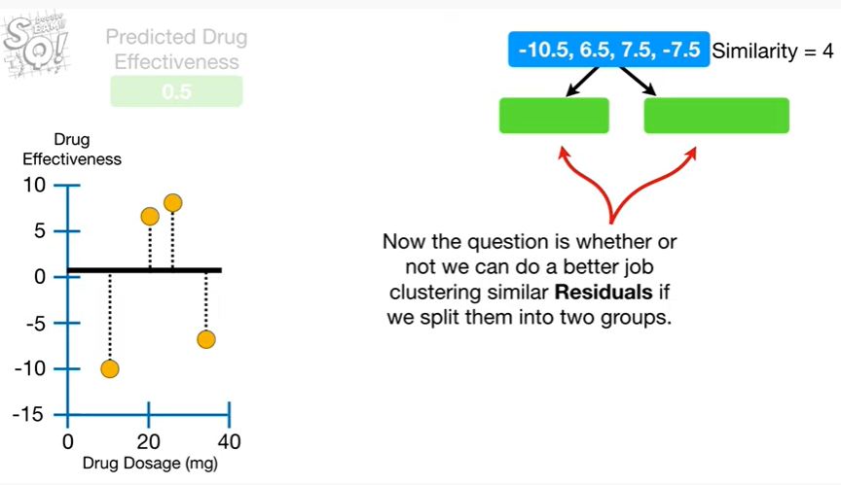

Now the question is whether or not we can do a better job clustering similar residuals if we split them into two groups.

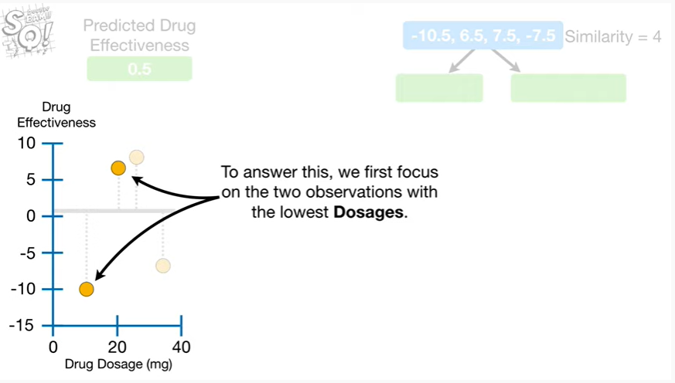

To answer this we first focus on the two observations with the lowest dosages.

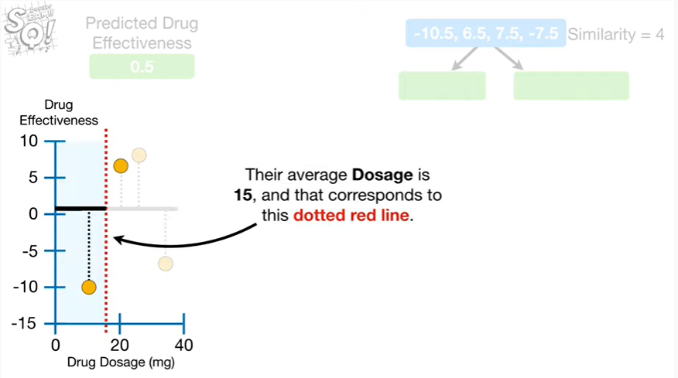

Their average dosage is 15, and that corresponds to this dotted red line.

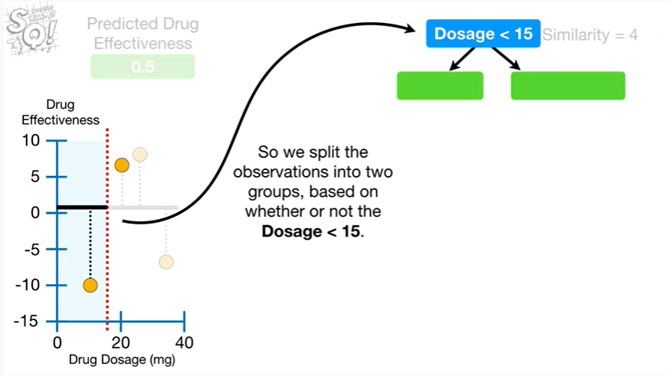

So we split the observations into two groups based on whether or not the dosage is less than 15.

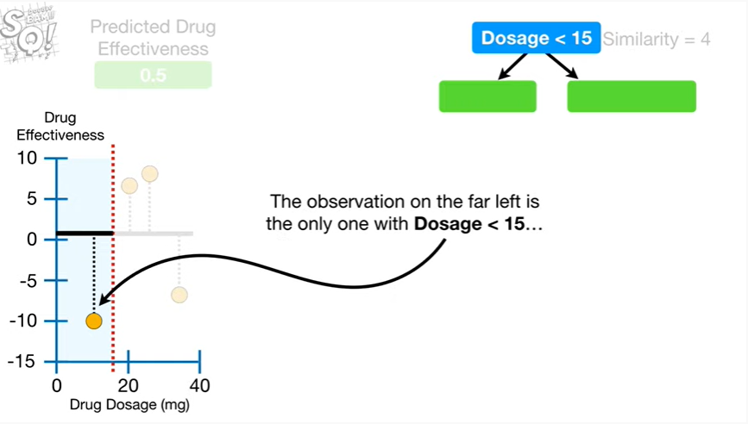

The observation on the far left is the only one with dosage less than 15

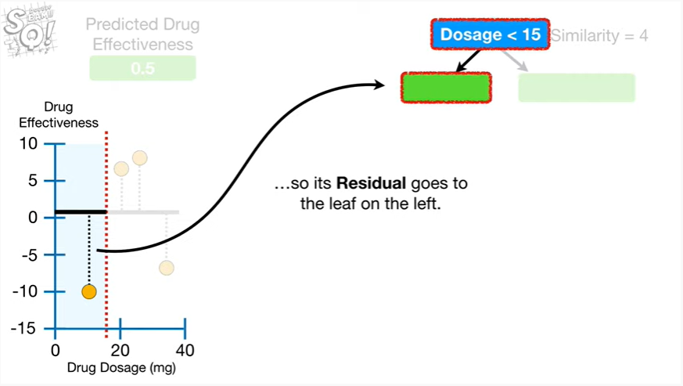

so it's residual goes to the leaf on the left.

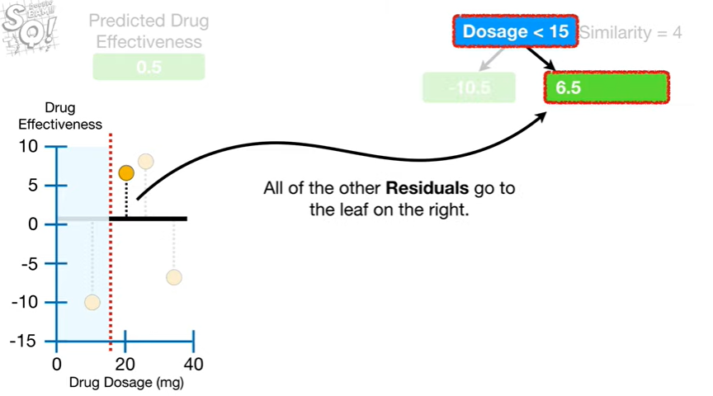

All of the other residuals go to the leaf on the right.

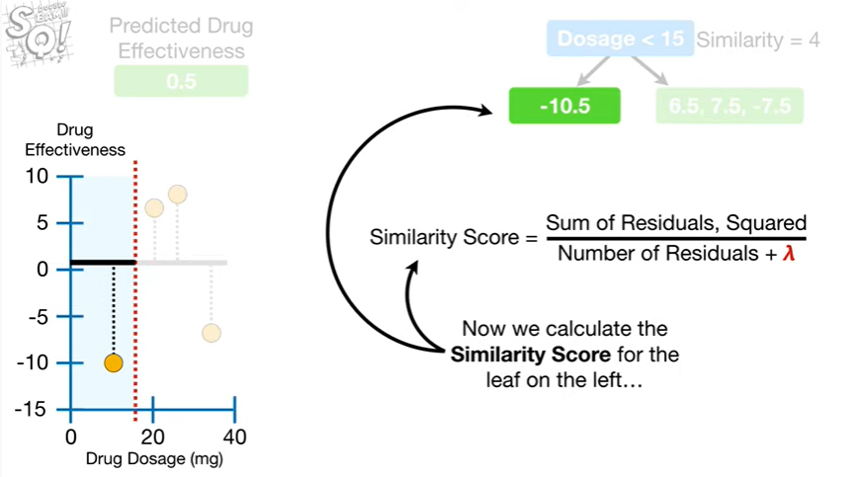

Now we calculate the similarity score for the leaf on the left

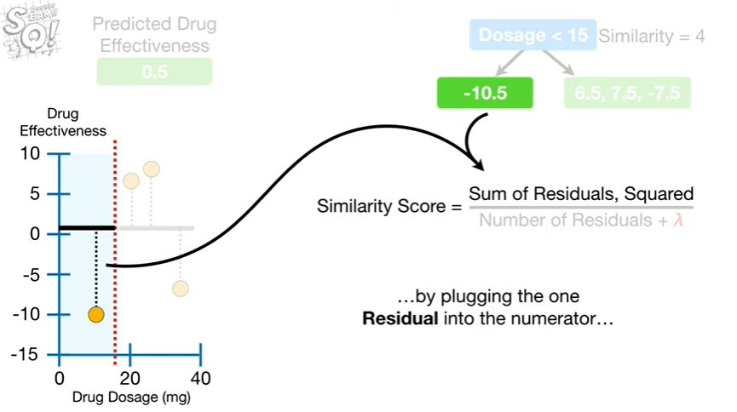

by plugging the 1 residual into the numerator

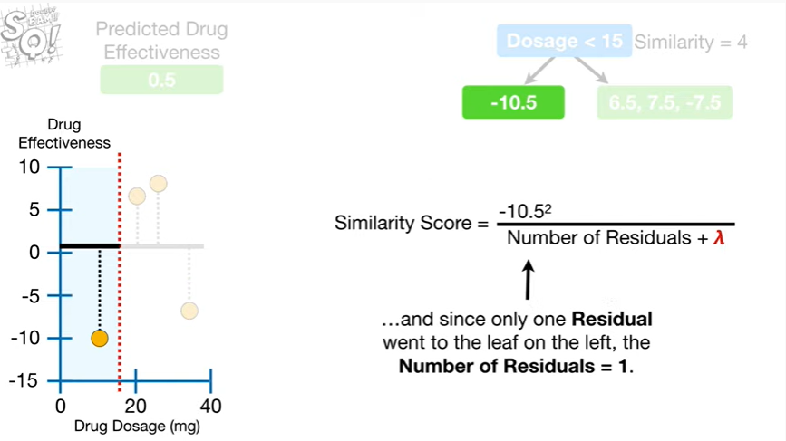

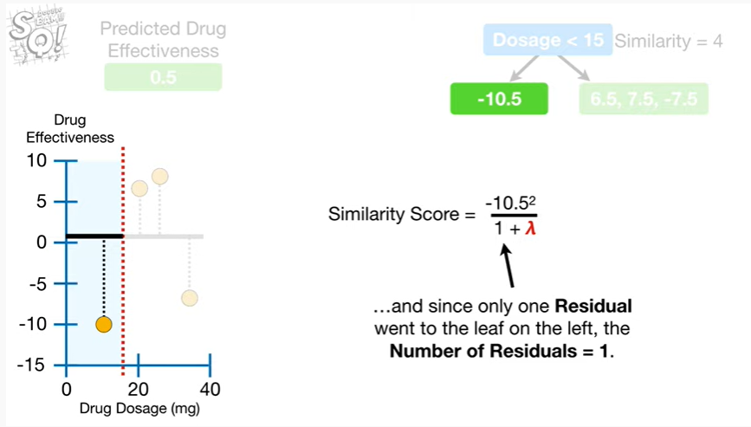

and since only one residual went to the leaf on the Left the number of residuals equals 1

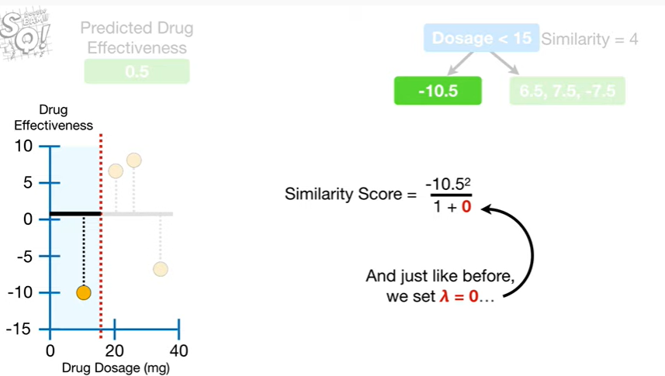

And just like before we set lambda equal to zero

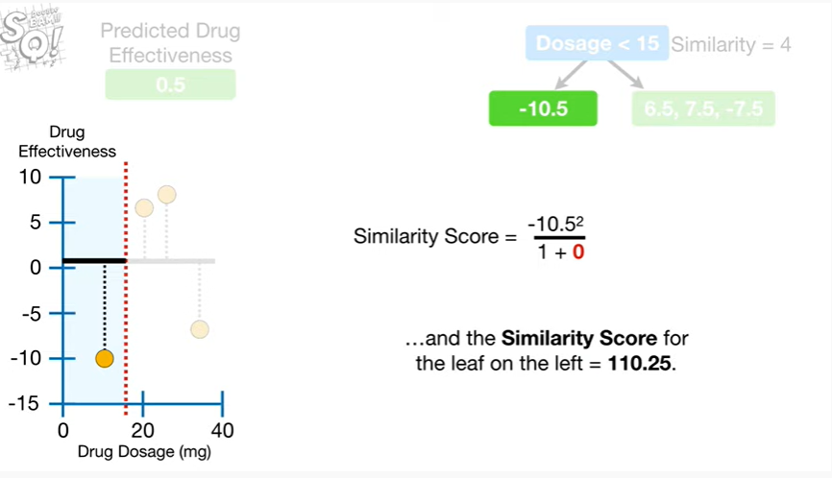

and the similarity score for the leaf on the Left equals 110 0.25.

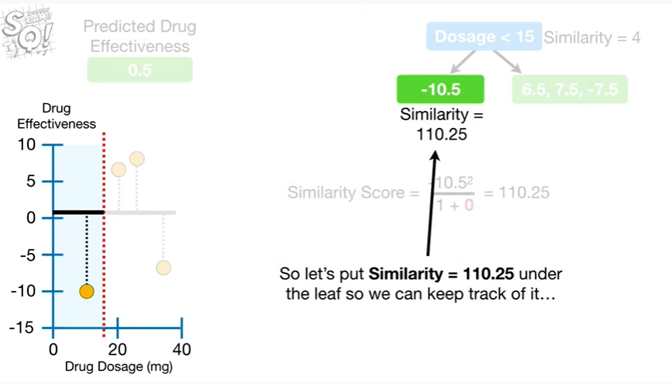

So let's put similarity equals 110 0.25 under the leaf so we can keep track of it

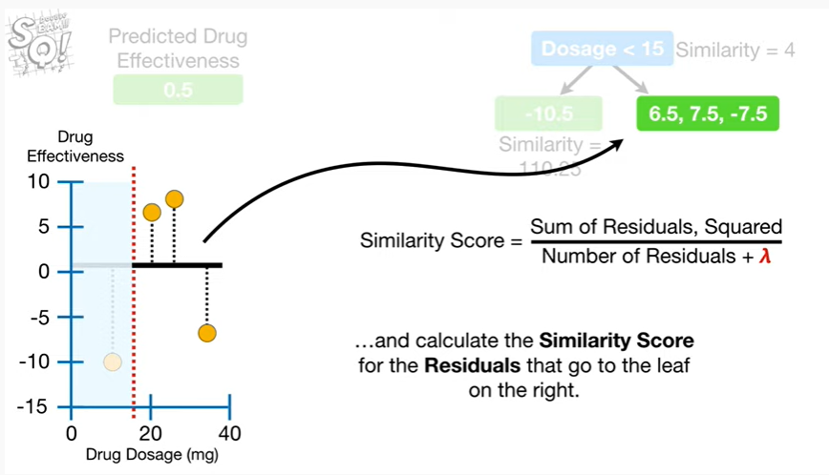

and calculate the similarity score for the residuals that go to the leaf on the right.

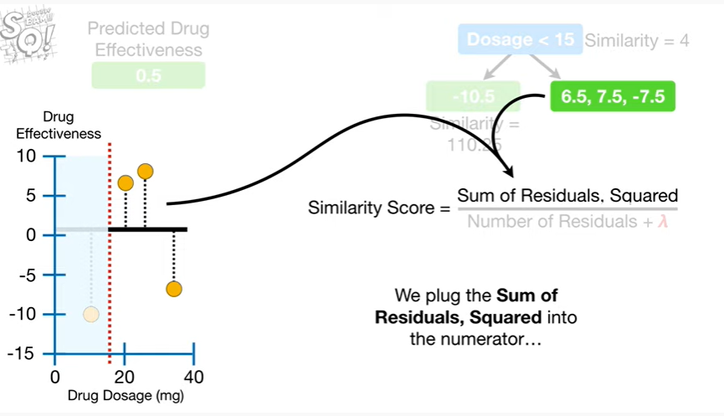

We plug in the sum of residuals squared into the numerator

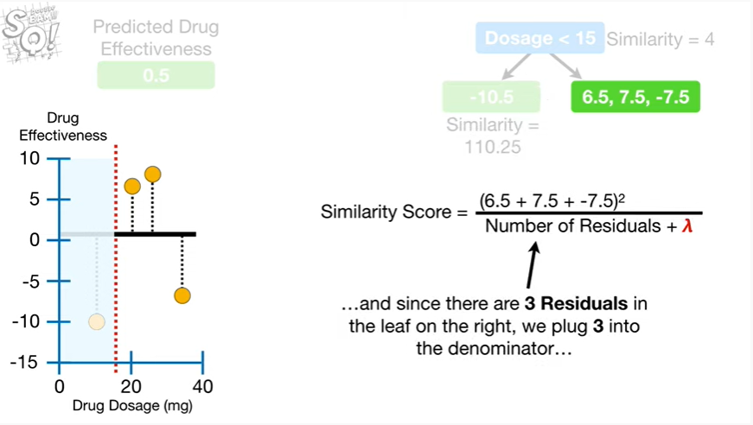

and since there are three residuals in the leaf on the right we plug 3 into the denominator

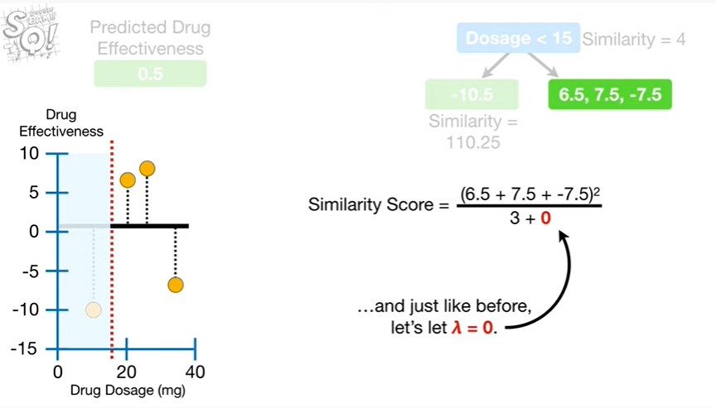

and just like before, let's let lambda equal zero.

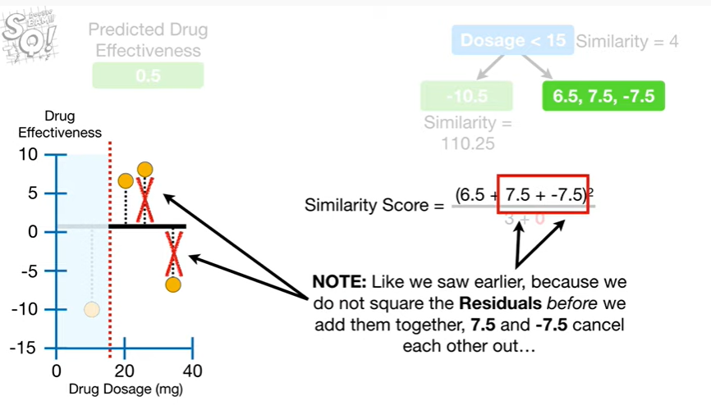

Note : like we saw earlier because we do not square the residuals before we add them together 7.5 and negative 7.5 cancel each other out

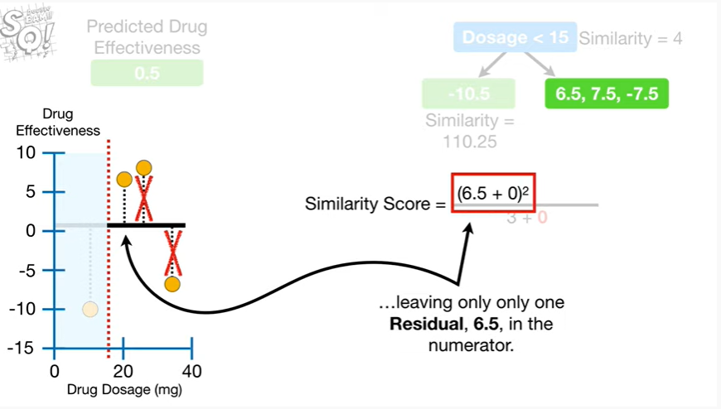

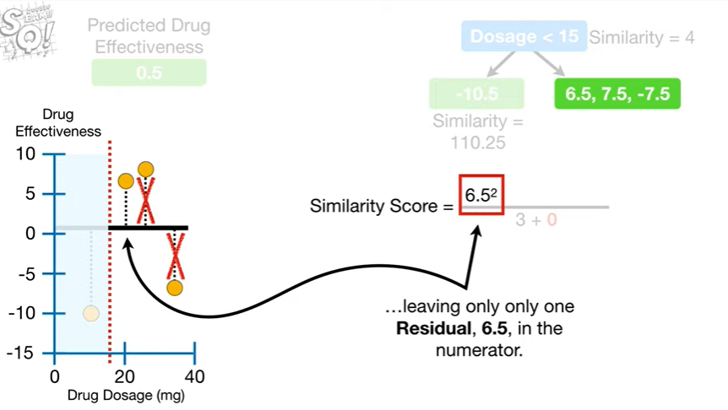

leaving only one residual 6.5 in the numerator.

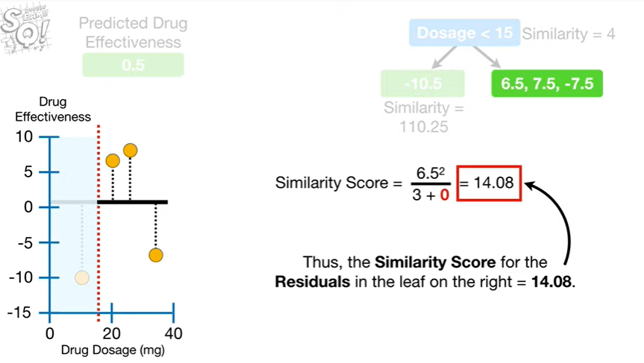

Thus, the similarity score for the residuals in the leaf on the right equals 14 point zero eight.

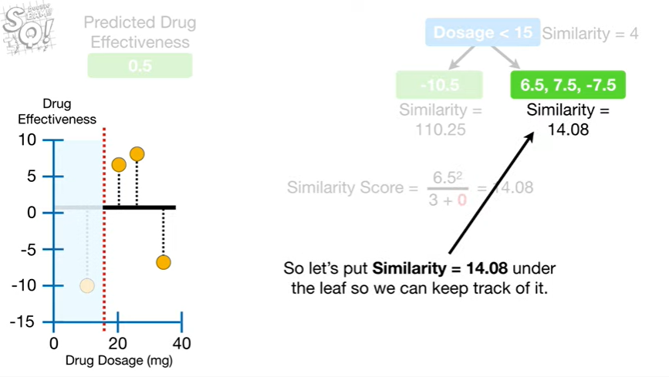

So let's put similarity equals 14 point zero eight under the leaf so we can keep track of it.

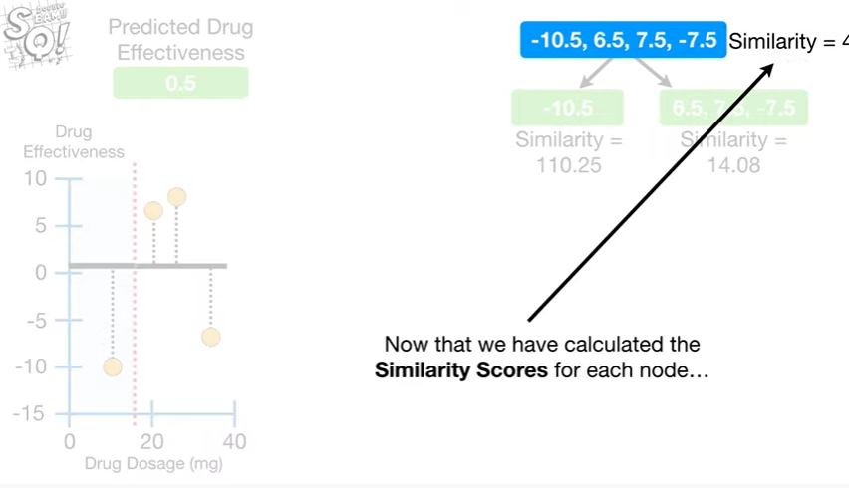

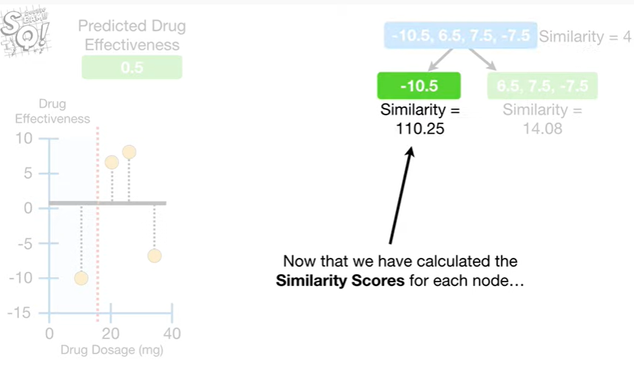

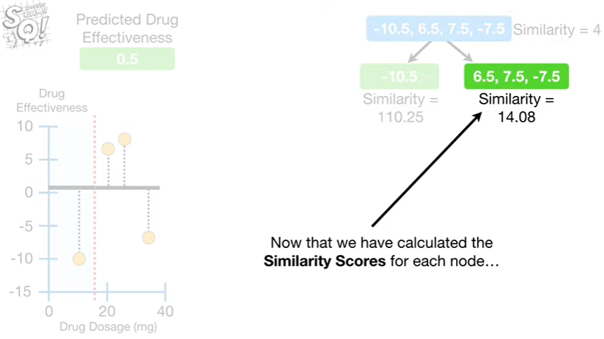

Now that we have calculated similarity scores for each node

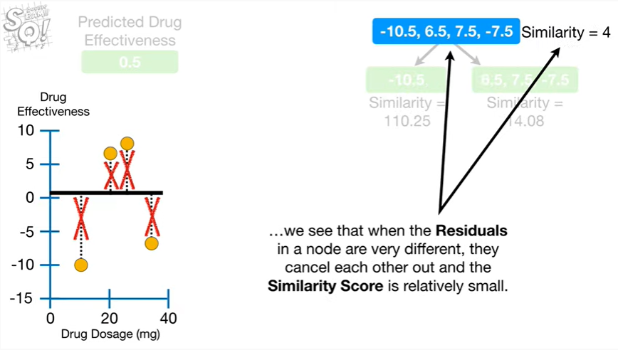

we see that when the residuals in a node are very different they cancel each other out and the similarity score is relatively small.

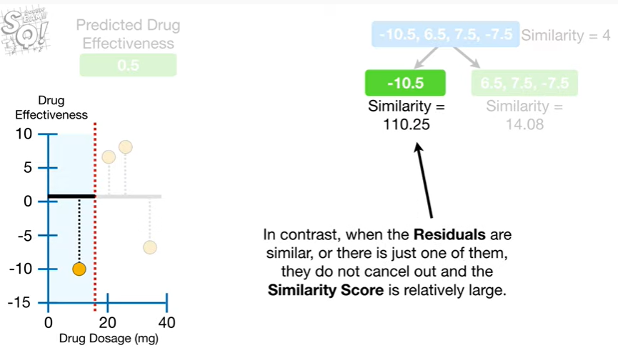

In contrast, when the residuals are similar or there is just one of them, they do not cancel out and the similarity score is relatively large.

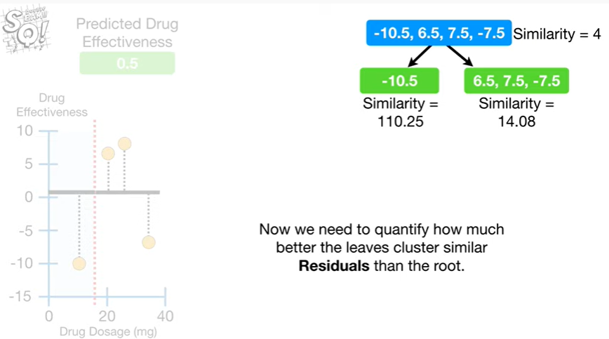

Now we need to quantify how much better the leaves cluster similar residuals than the root.

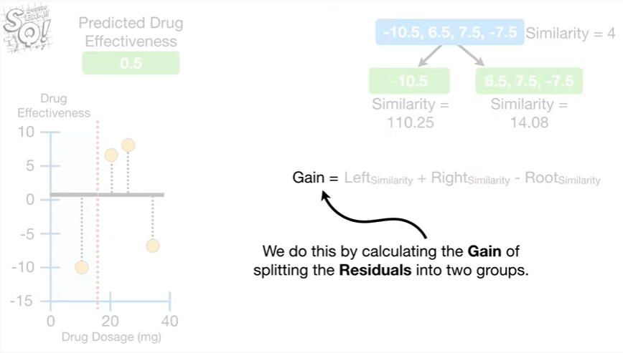

We do this by calculating the gain of splitting the residuals into two groups.

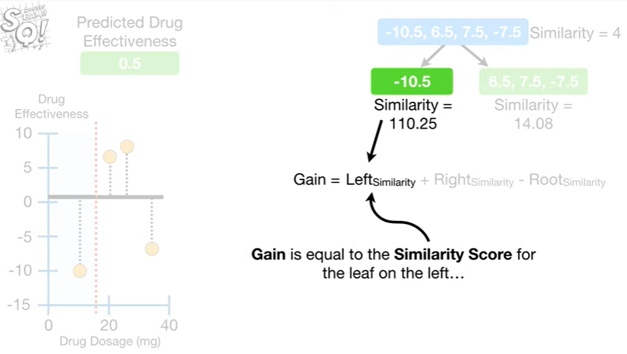

Gain is equal to the similarity score for the leaf on the Left

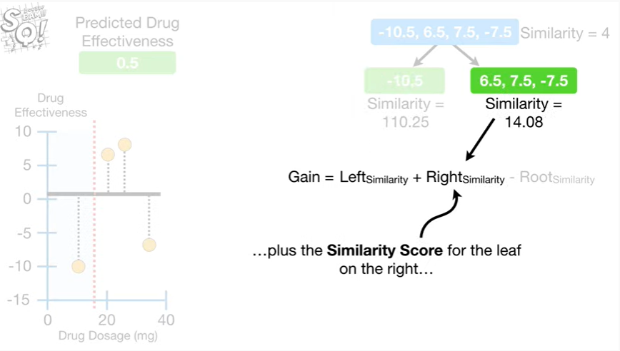

plus the similarity score for the leaf on the right

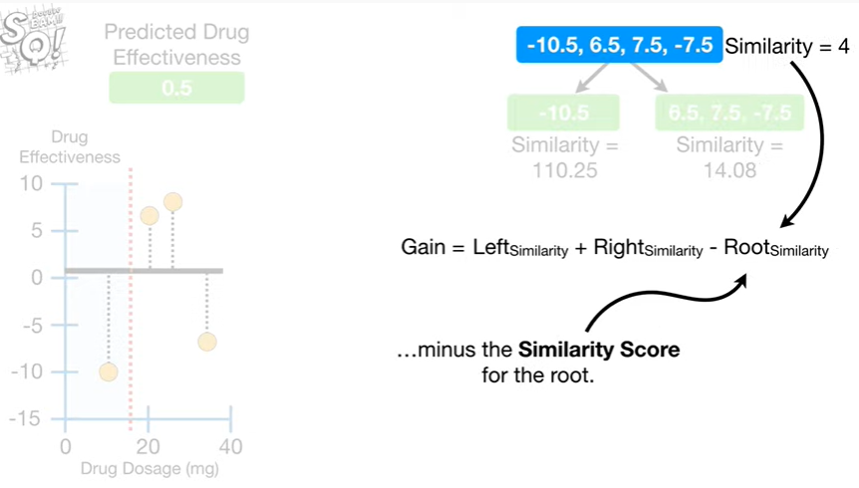

minus the similarity score for the root.

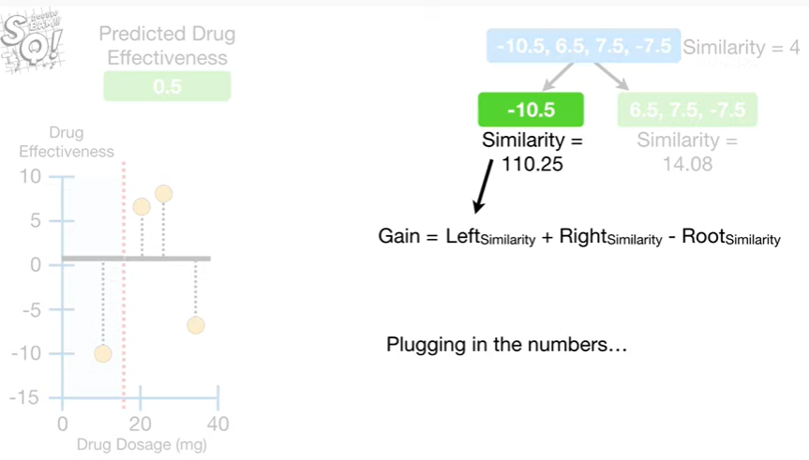

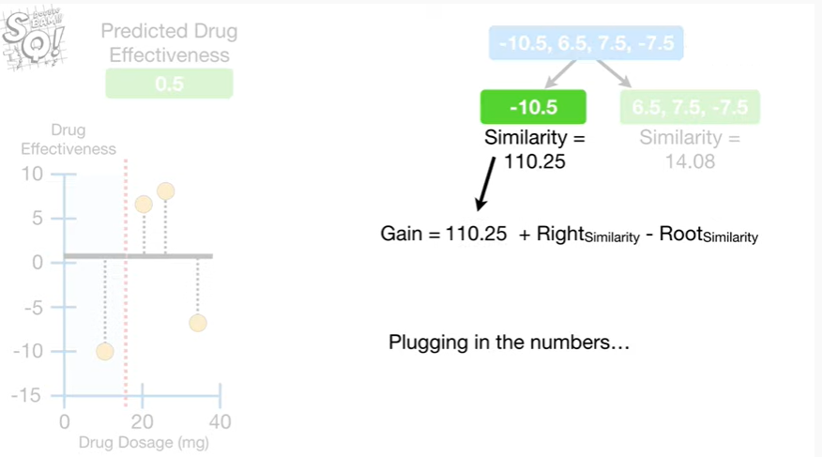

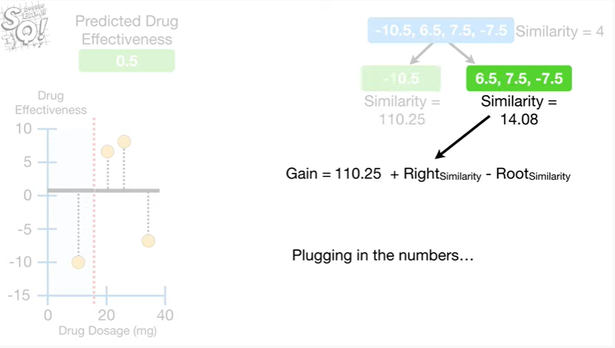

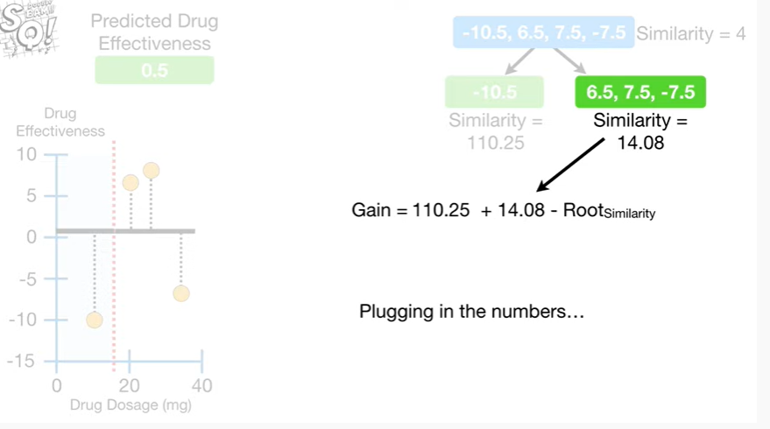

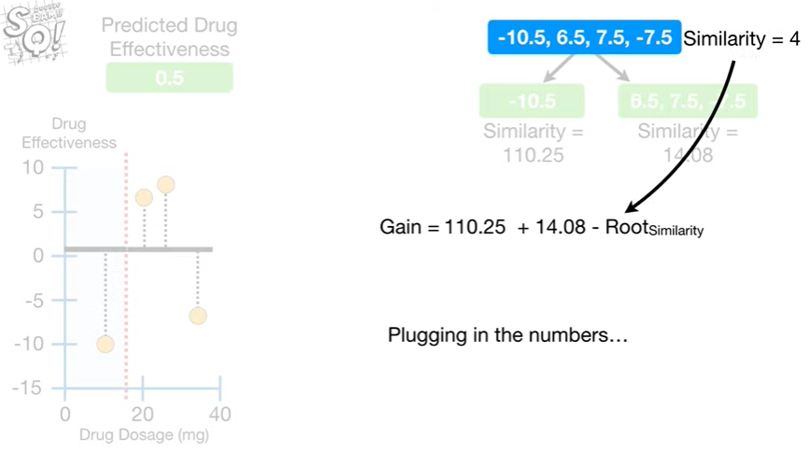

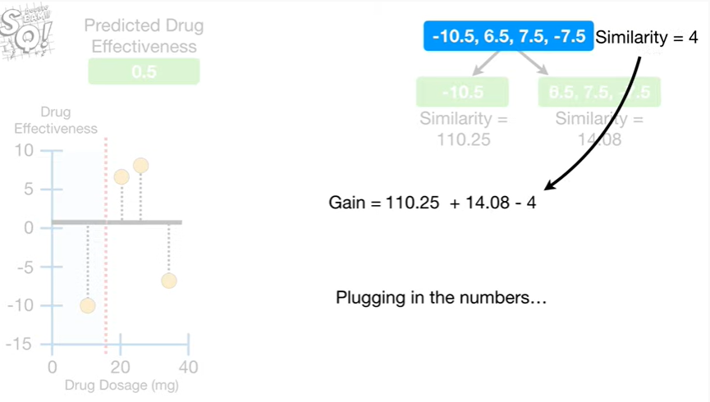

Plugging in the numbers

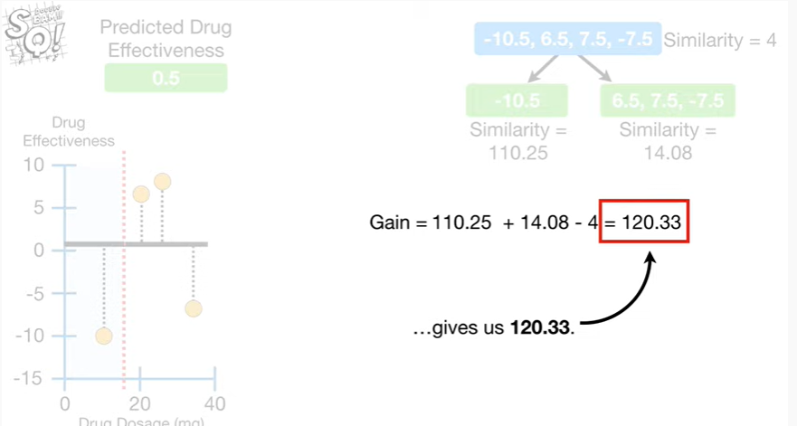

gives us 120 point three three.

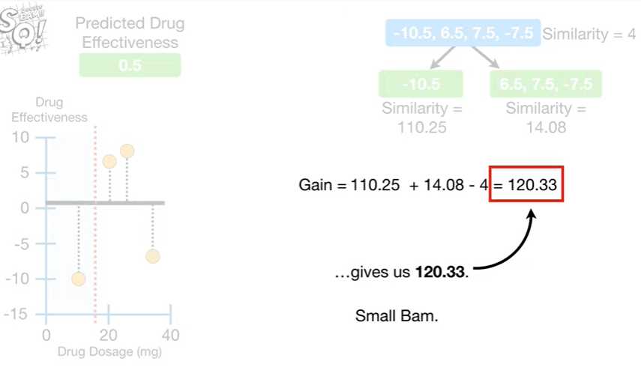

Small BAM.

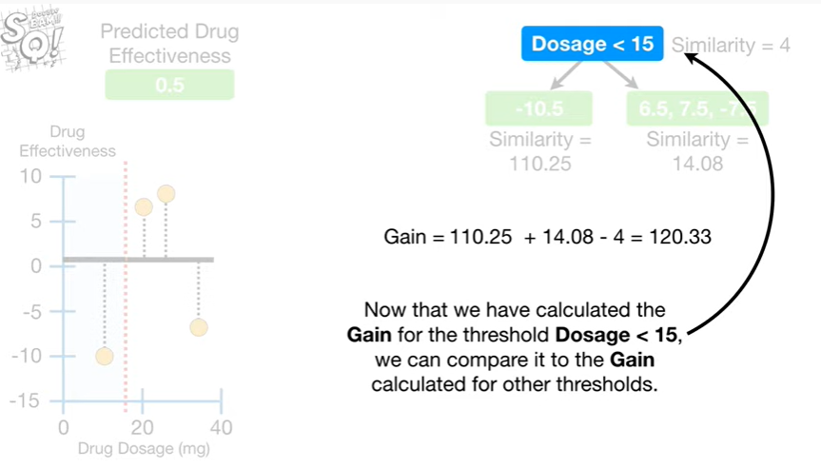

Now that we have calculated the gain for the threshold of dosage less than 15, we can compare it to the gain calculated for other thresholds.

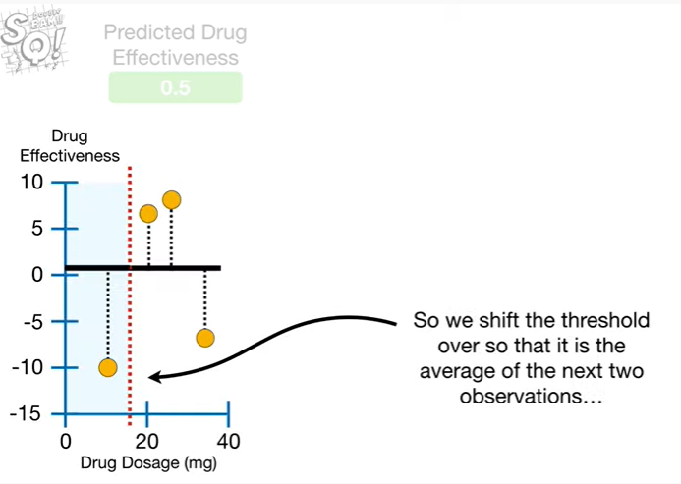

So we shift the threshold over so that it is the average of the next two observations

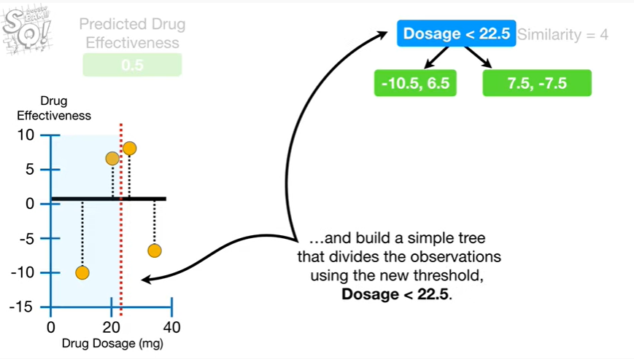

and build a simple tree that divides the observations using the new threshold dosage less than twenty two point five.

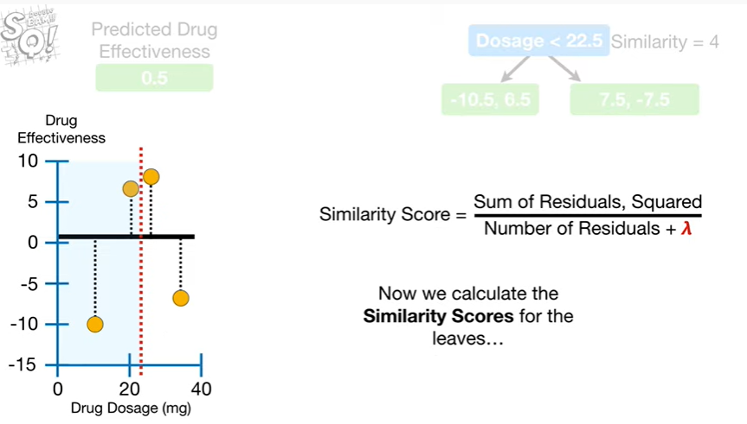

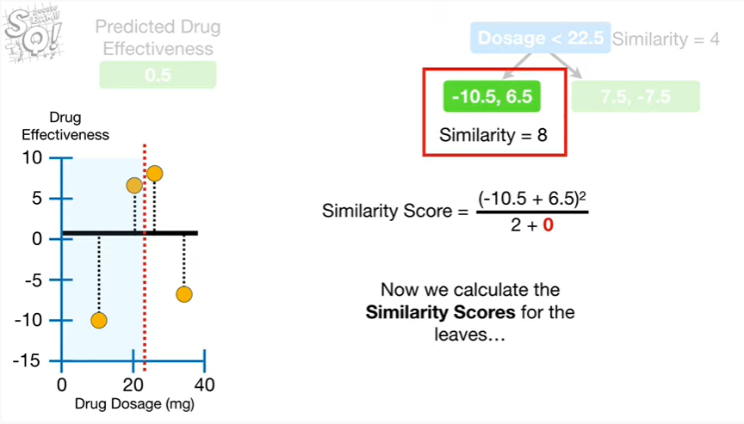

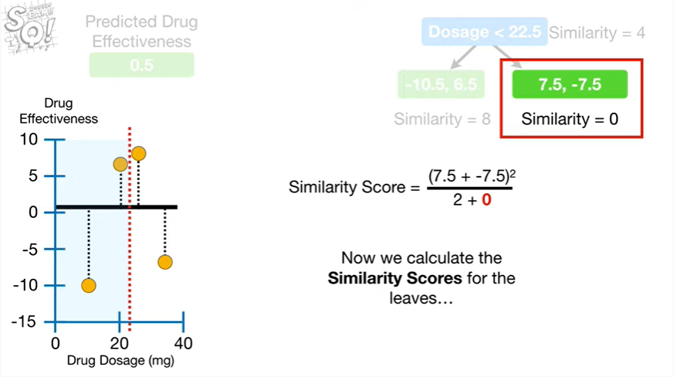

Now we calculate the similarity scores for the leaves

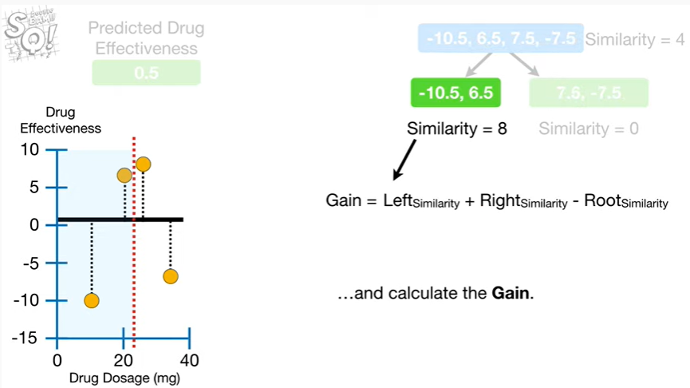

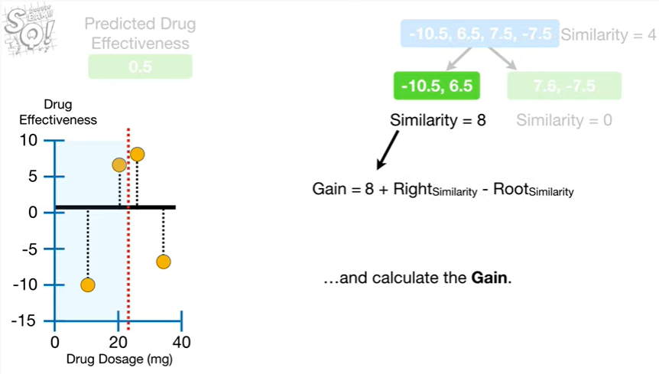

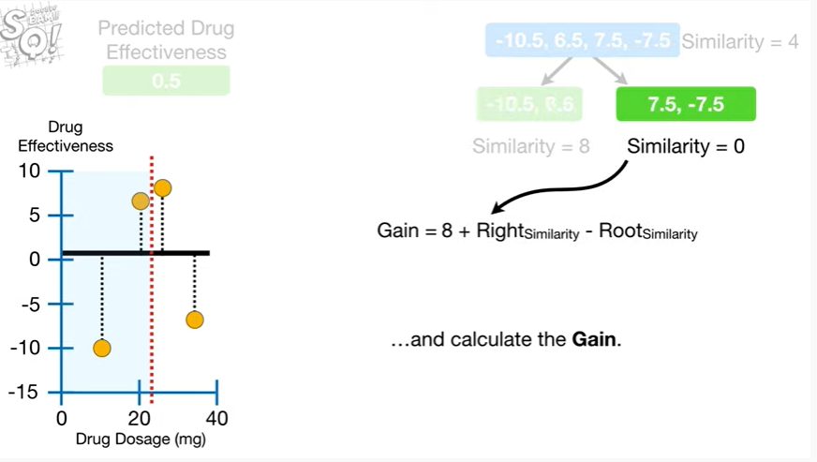

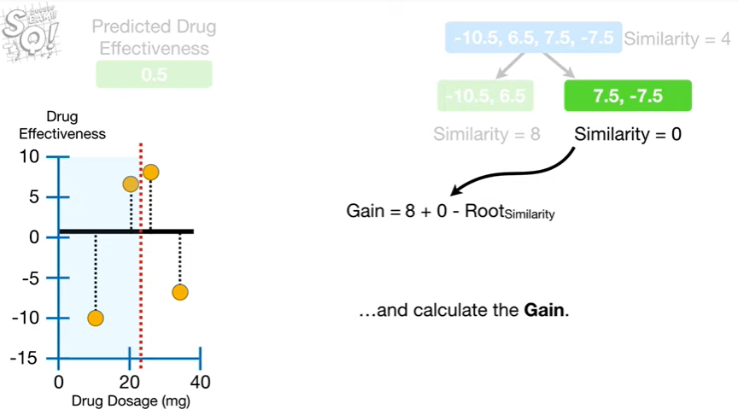

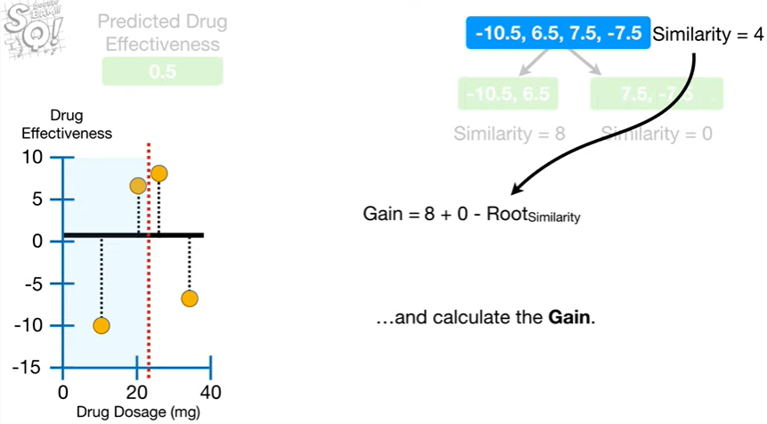

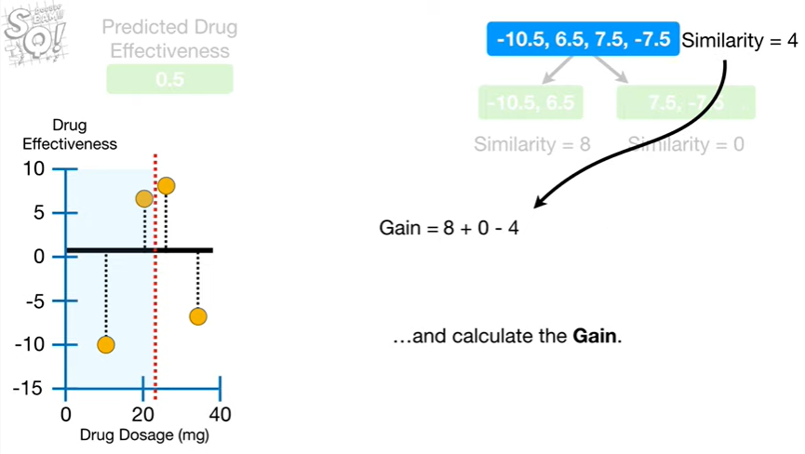

and calculate the gain.

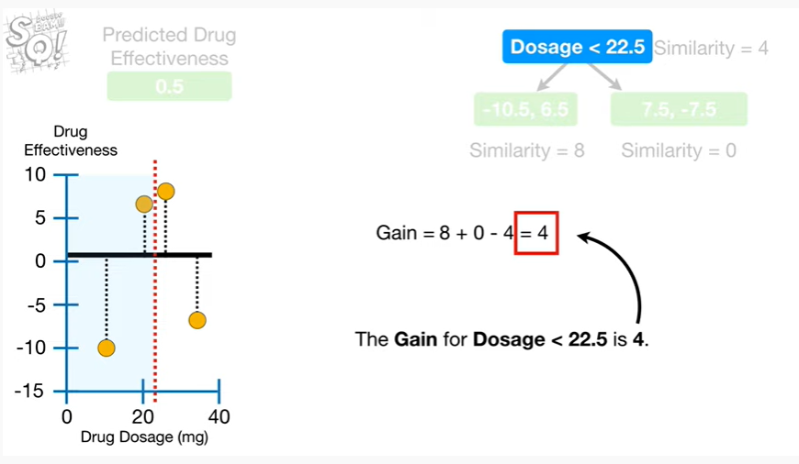

The gain for dosage less than twenty two point five is four.

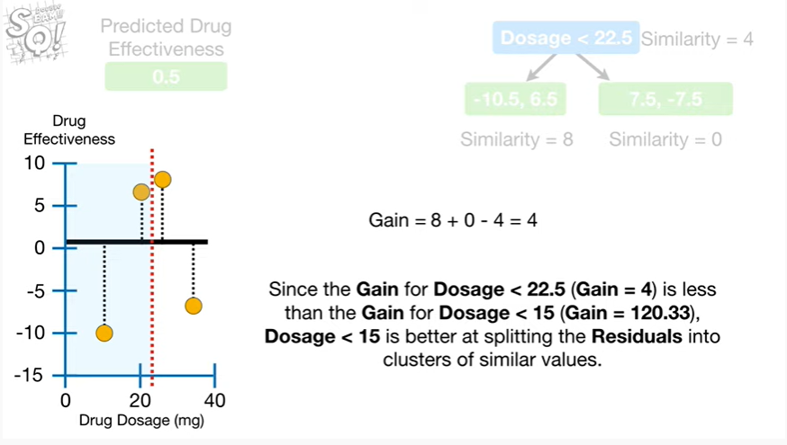

Since the gain for dosage less than twenty two point five is less than the game for dosage less than fifteen, dosage less than fifteen is better at splitting the residuals into clusters of similar values.

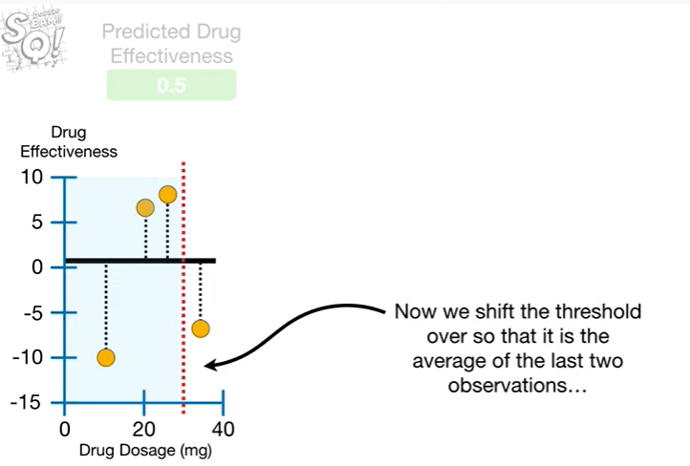

Now we shift the threshold over so that it is the average of the last two observations

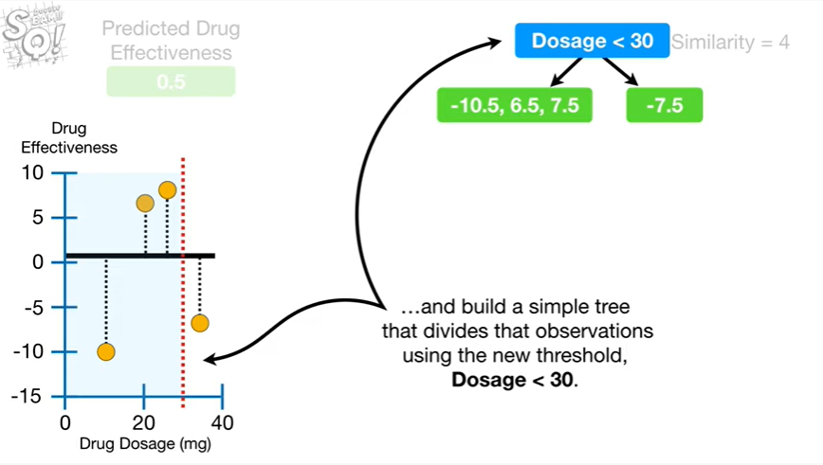

and build a simple tree that divides the observations using the new threshold dosage less than 30.

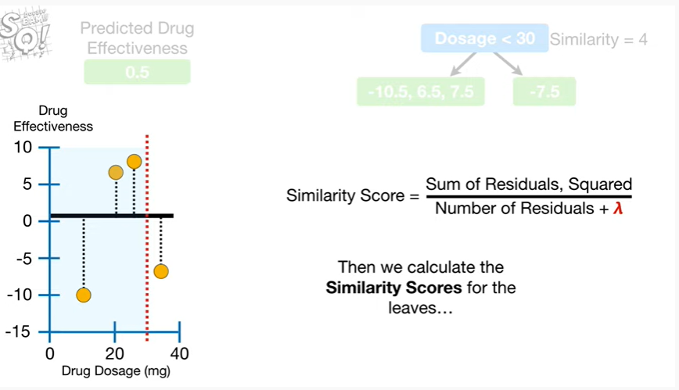

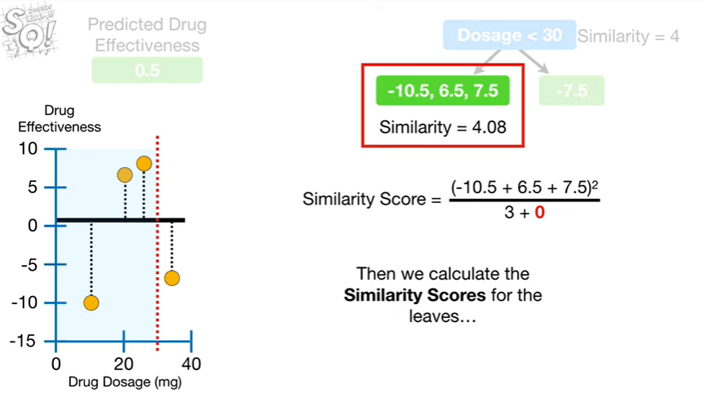

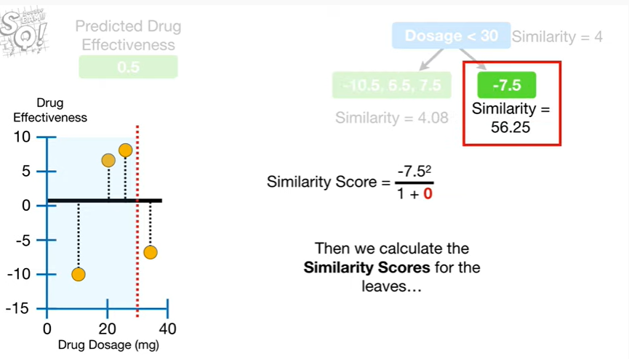

Then we calculate the similarity scores for the leaves

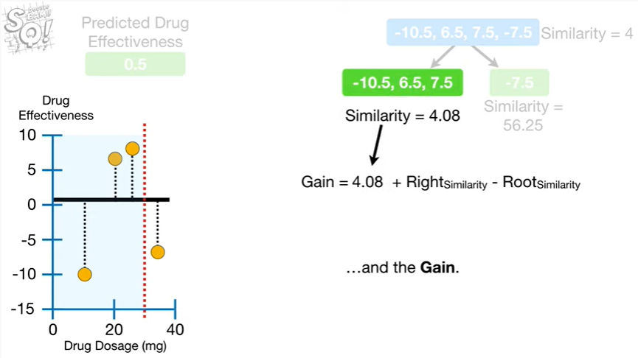

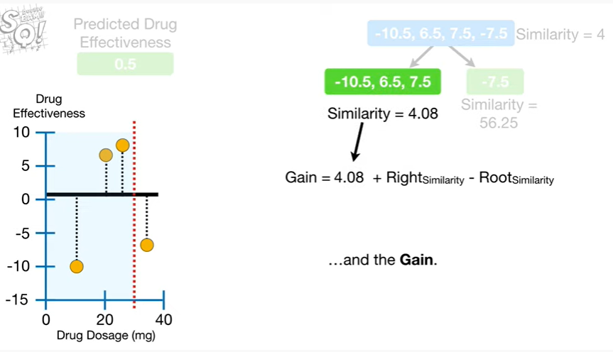

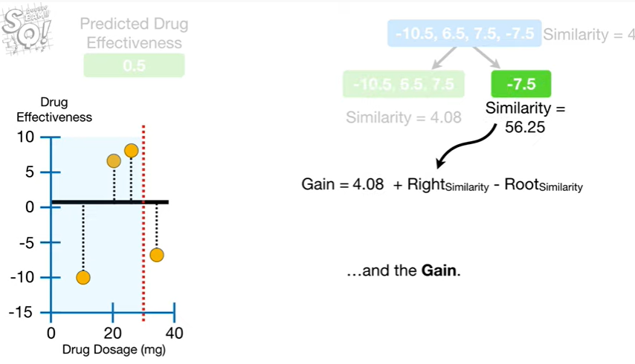

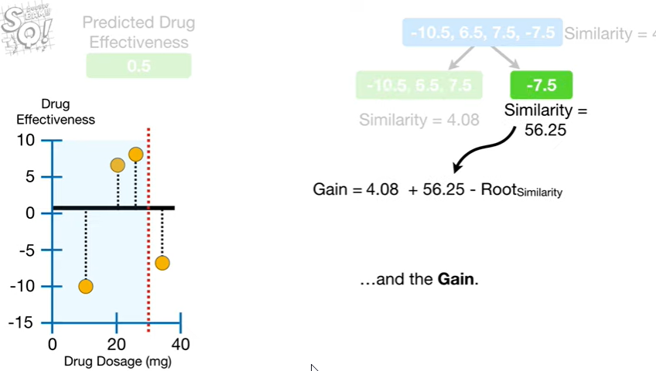

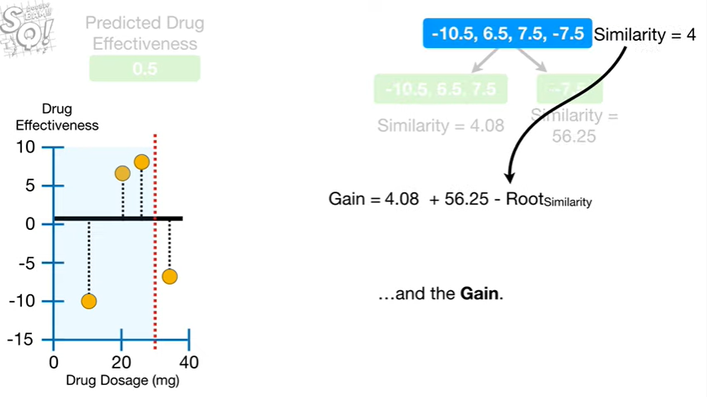

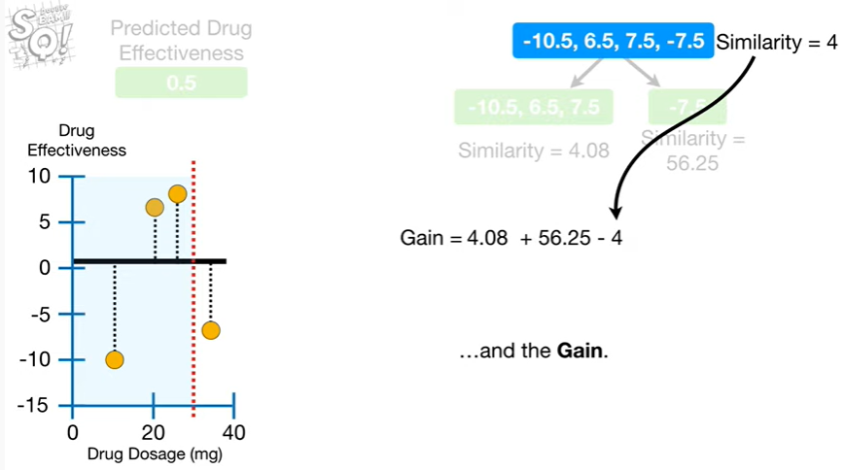

and the gain.

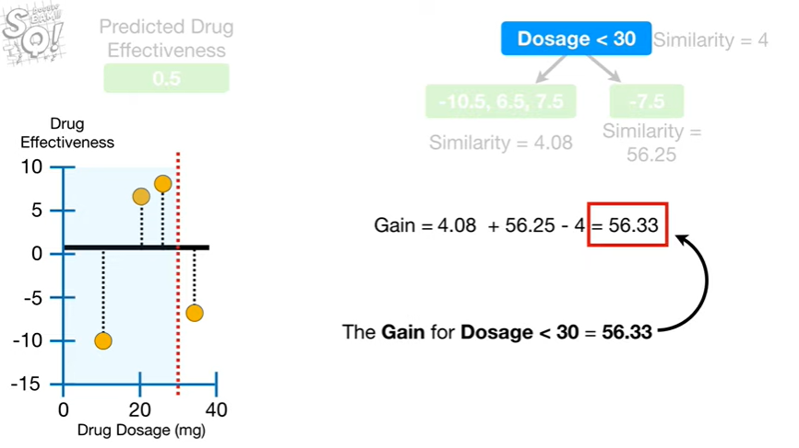

The gain for dosage less than thirty equals fifty six point three three.

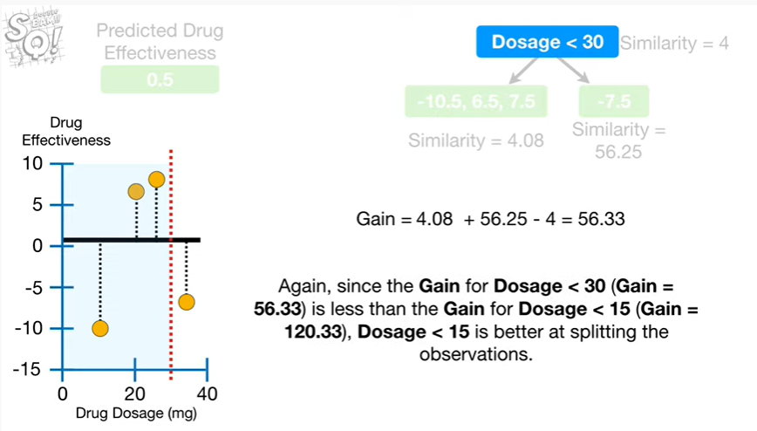

Again since the gain for dosage less than 30 is less than the game for dosage less than 15, dosage less than 15 is better at splitting the observations.

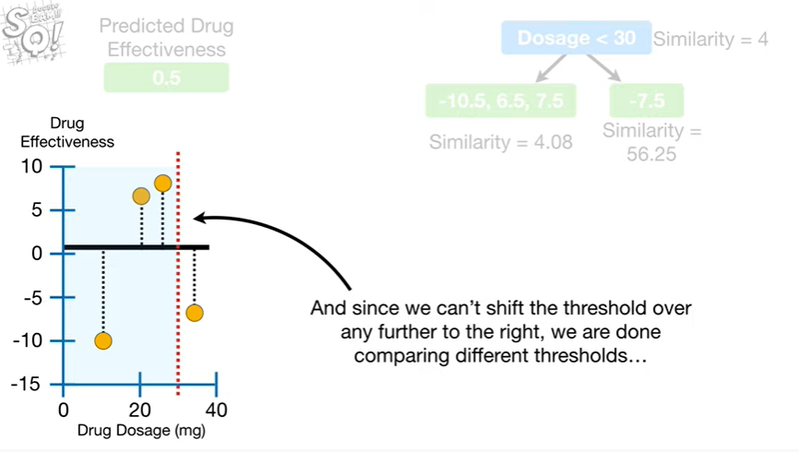

And since we can't shift the threshold over any further to the right, we are done comparing different thresholds

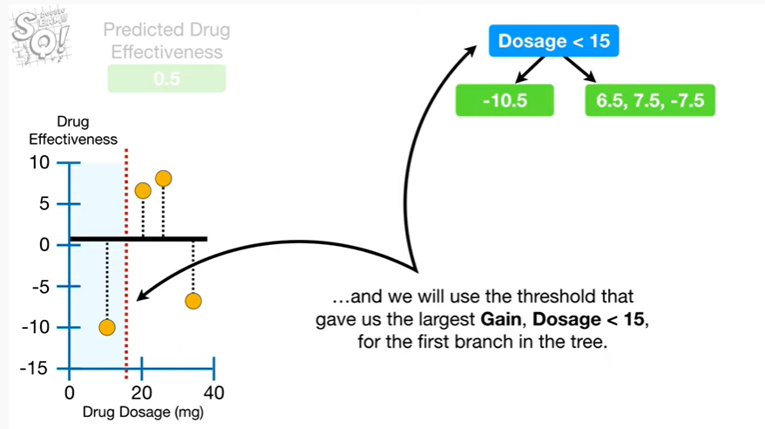

and we will use the threshold that gave us the largest gain dosage less than 15 for the first branch in the tree.

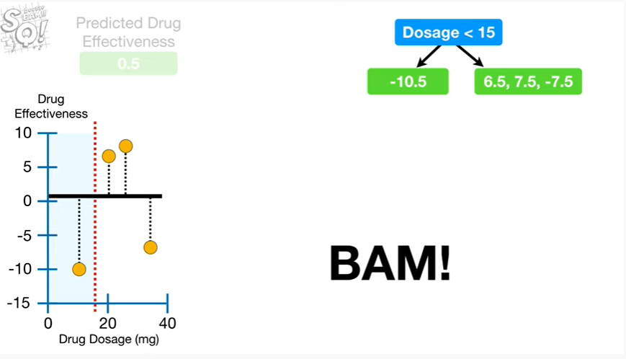

BAM !!!

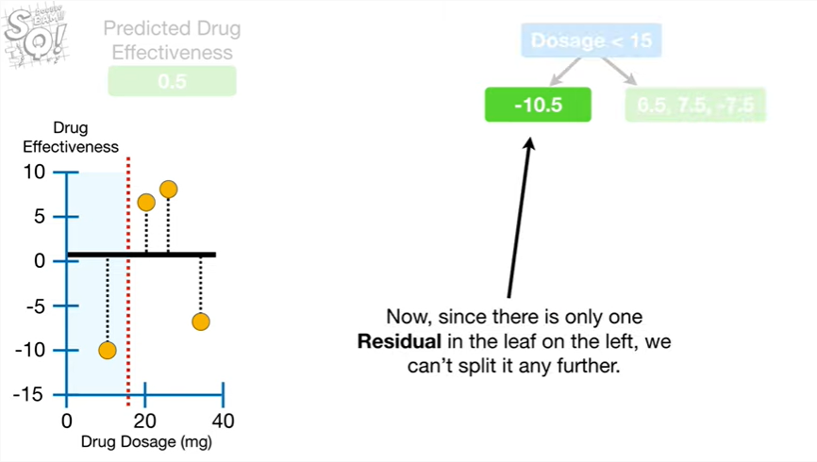

Now, since there is only one residual in the leaf on the Left, we can't split it any further.

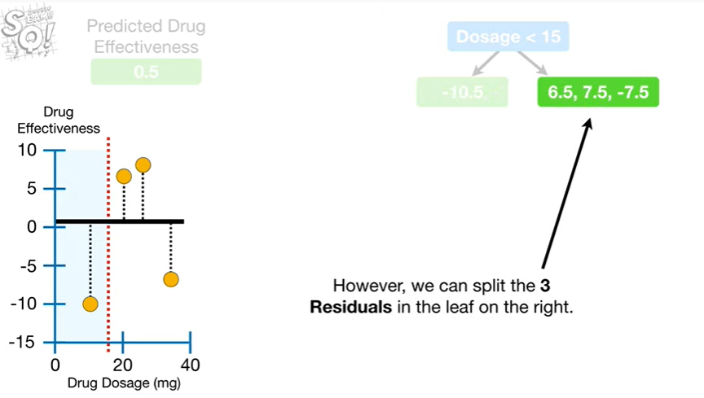

However, we can split the three residuals in the leaf on the right.

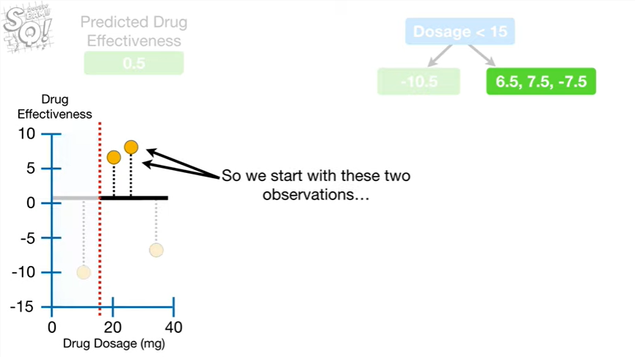

So we start with these two observations

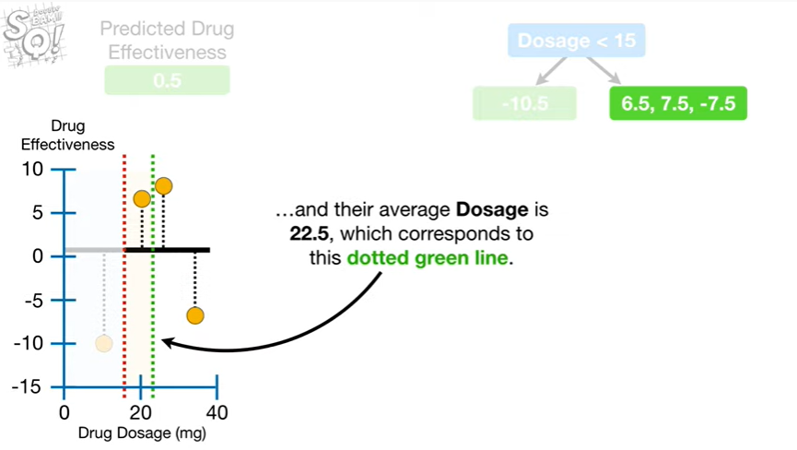

and their average dosage is twenty-two point five which corresponds to this dotted green line.

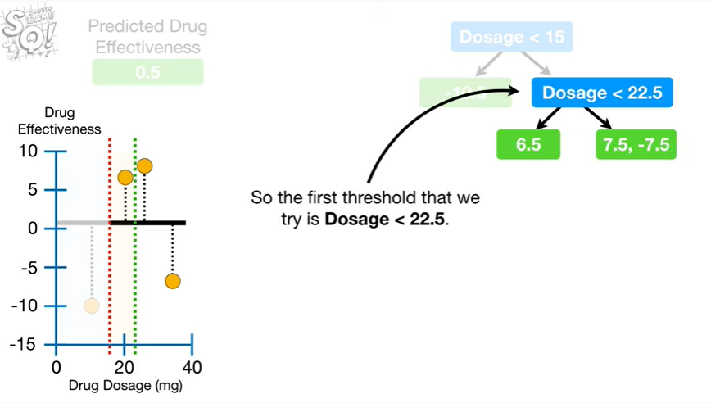

So the first threshold that we try is dosage less than twenty two point five.

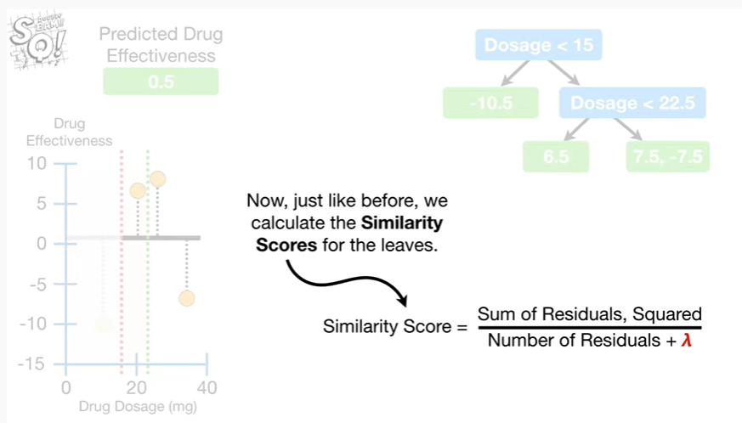

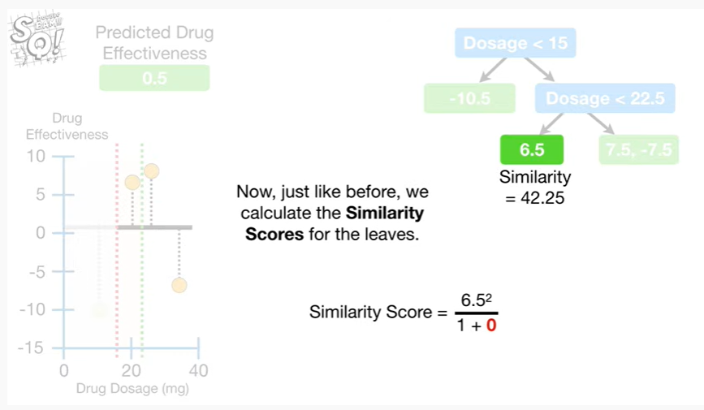

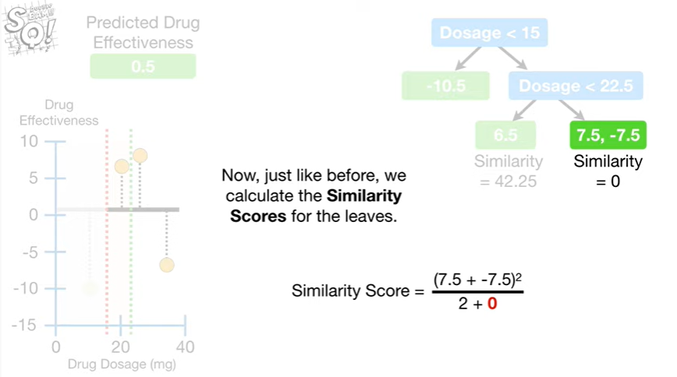

Now, just like before we calculate the similarity scores for the leaves.

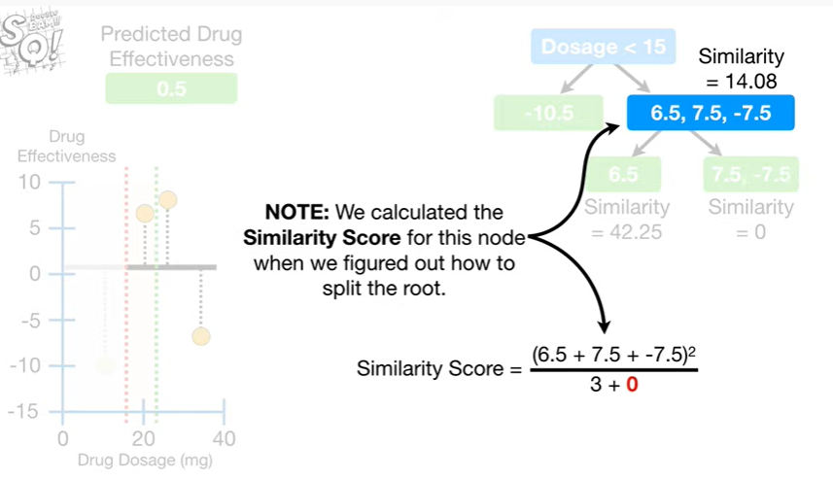

Note : we calculated the similarity score for this node when we figured out how to split the root.

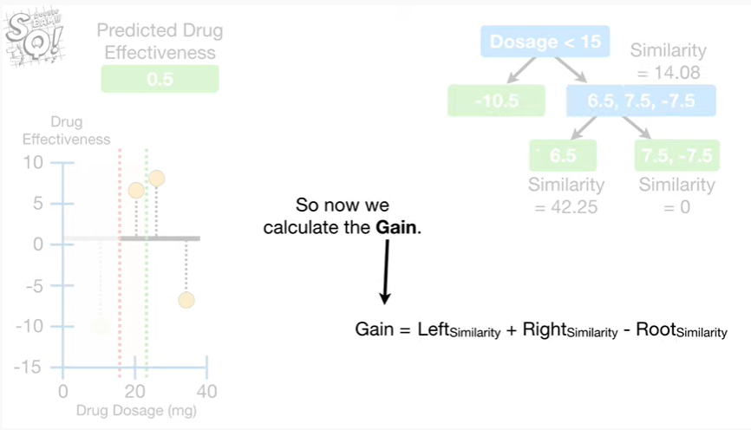

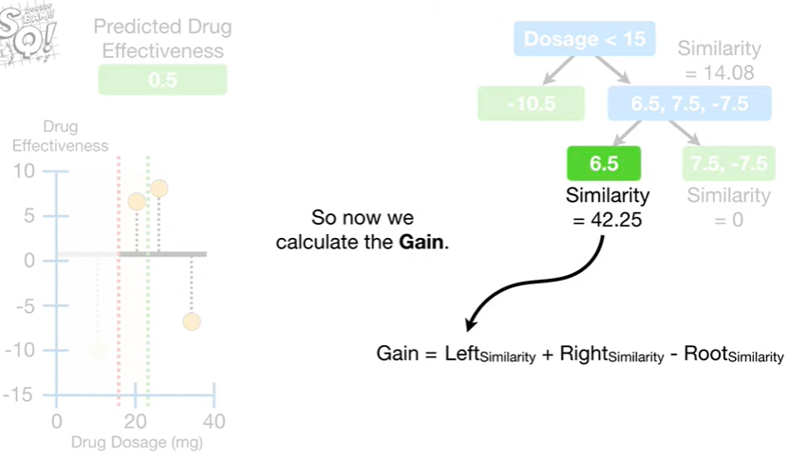

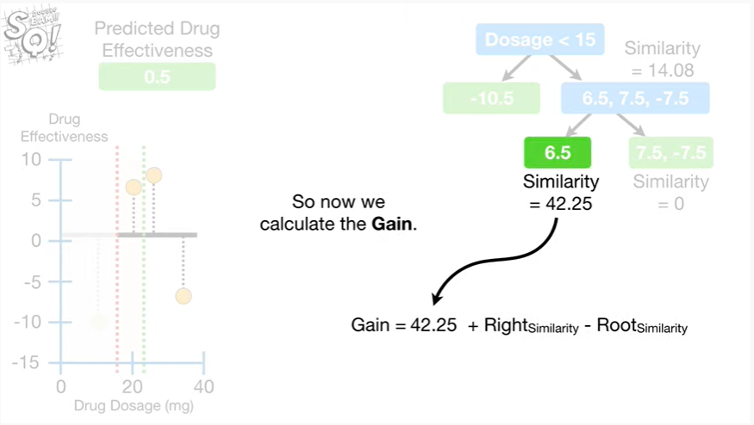

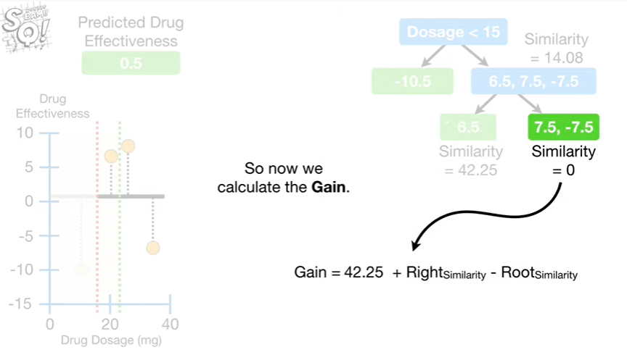

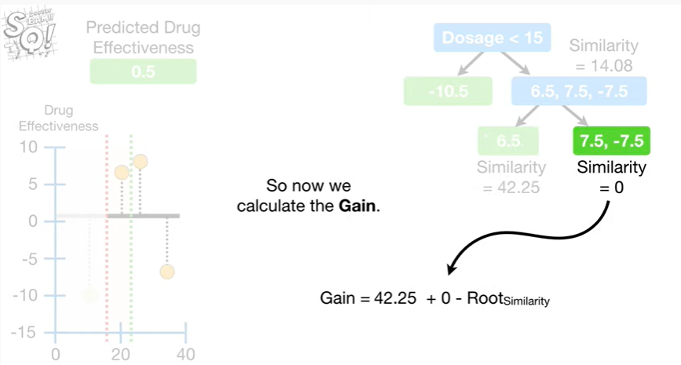

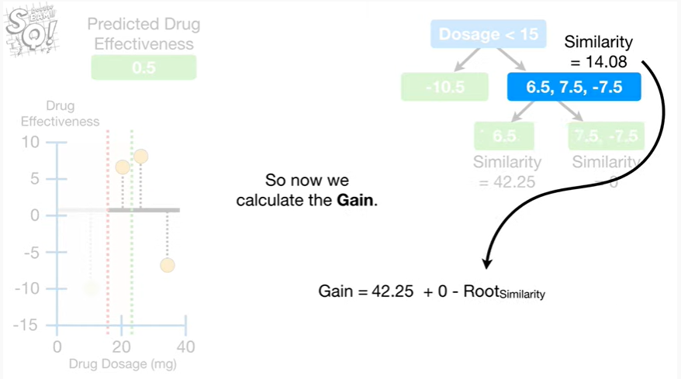

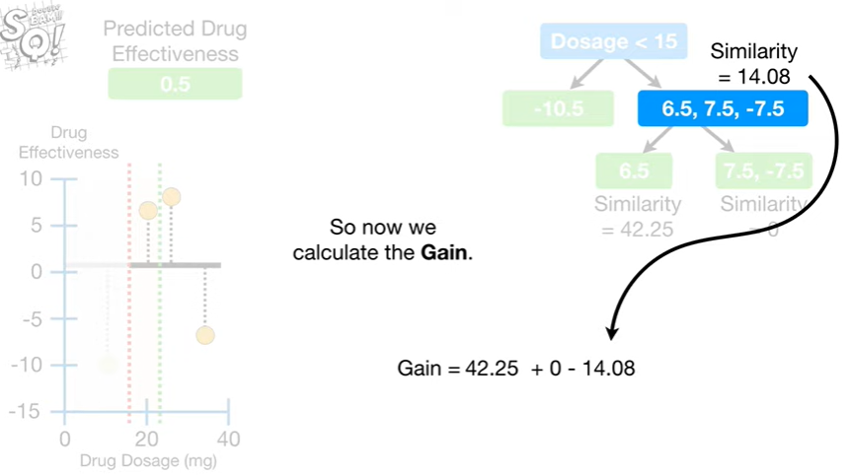

So now we calculate the gain.

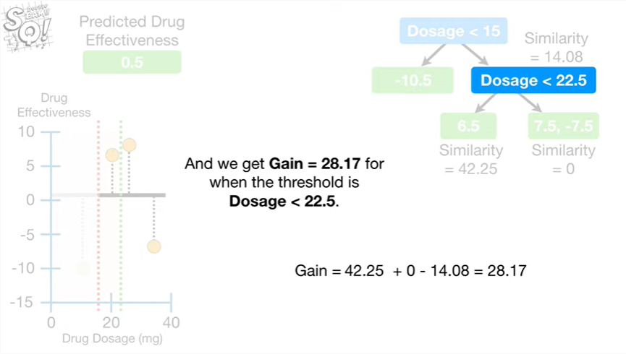

And we get gain equals twenty eight point one seven four when the threshold is dosage less than twenty two point five.

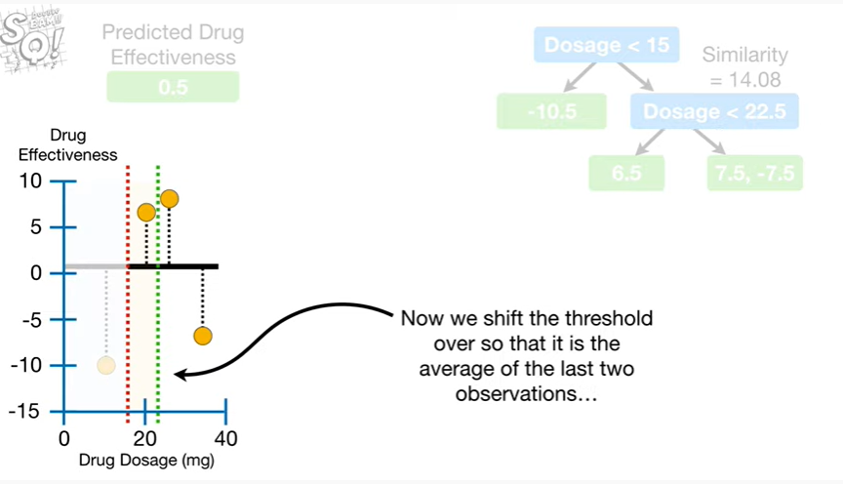

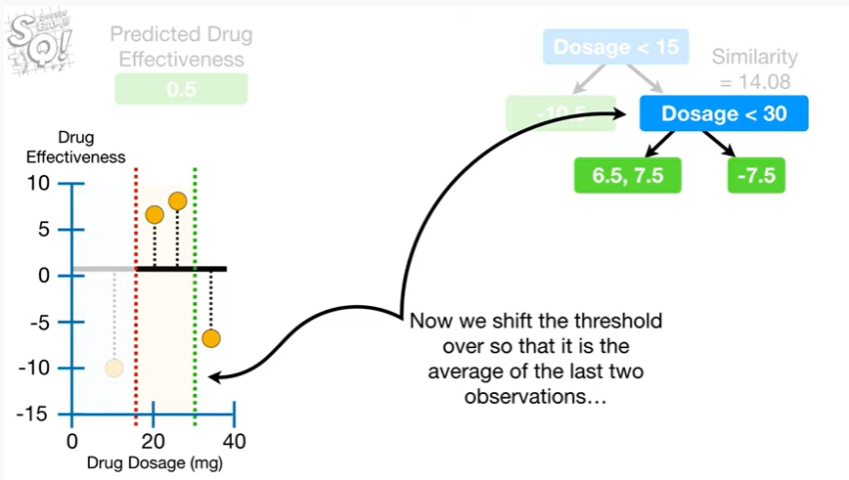

Now we shift the threshold over so that it is the average of the last two observations

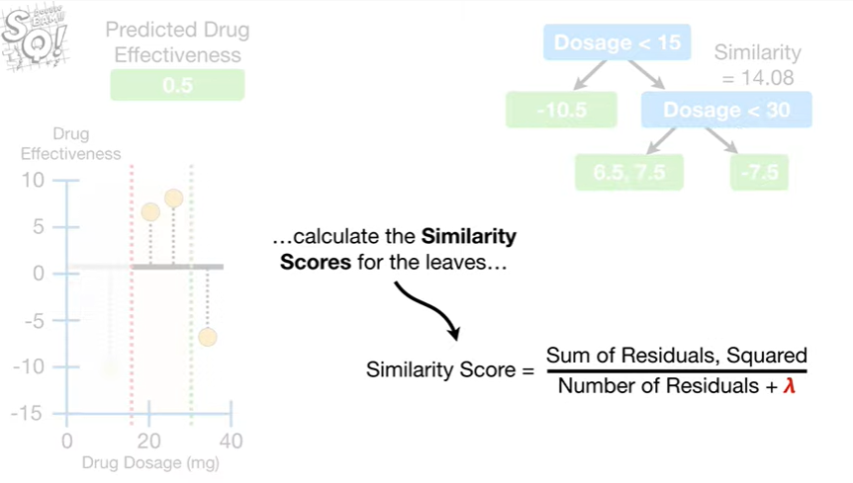

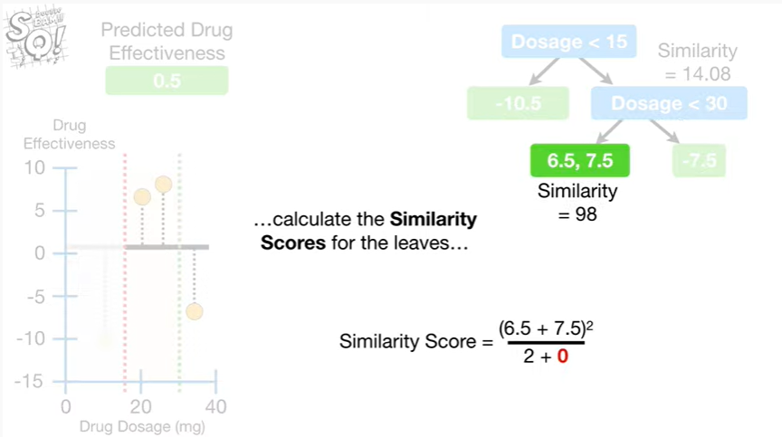

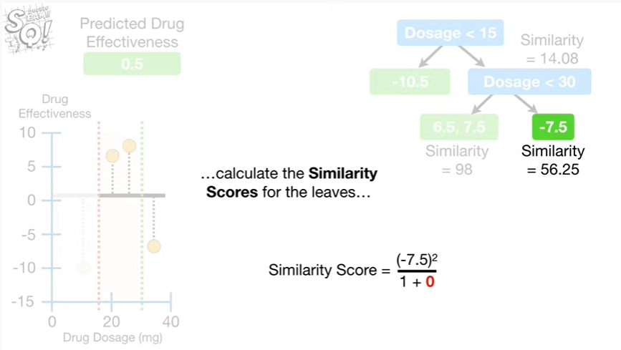

calculate the similarity scores for the leaves

